Year 10 |  | Linear Relations | Non Calculator
Skills and Knowledge Assessed:  - Sketch linear graphs using the coordinates of two points and solve linear equations (ACMNA215)  - Solve problems involving parallel and perpendicular lines (ACMNA238) |  |  | Name_________________
Section 1 Short Answer Section
Write all working and answers in the spaces provided on this test paper.

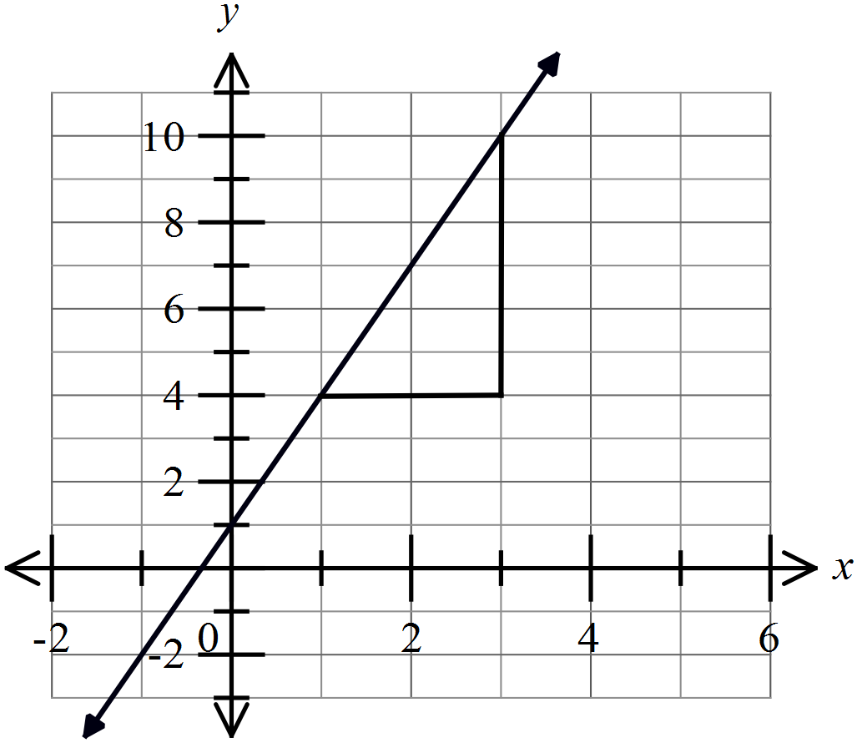What is the gradient of the line shown below?

………………………………………………

……………………………………………....

………………………………………………

……………………………………………….

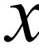 | 1 | 2 | 3 | 4
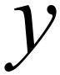 |  | 9 |  | 6

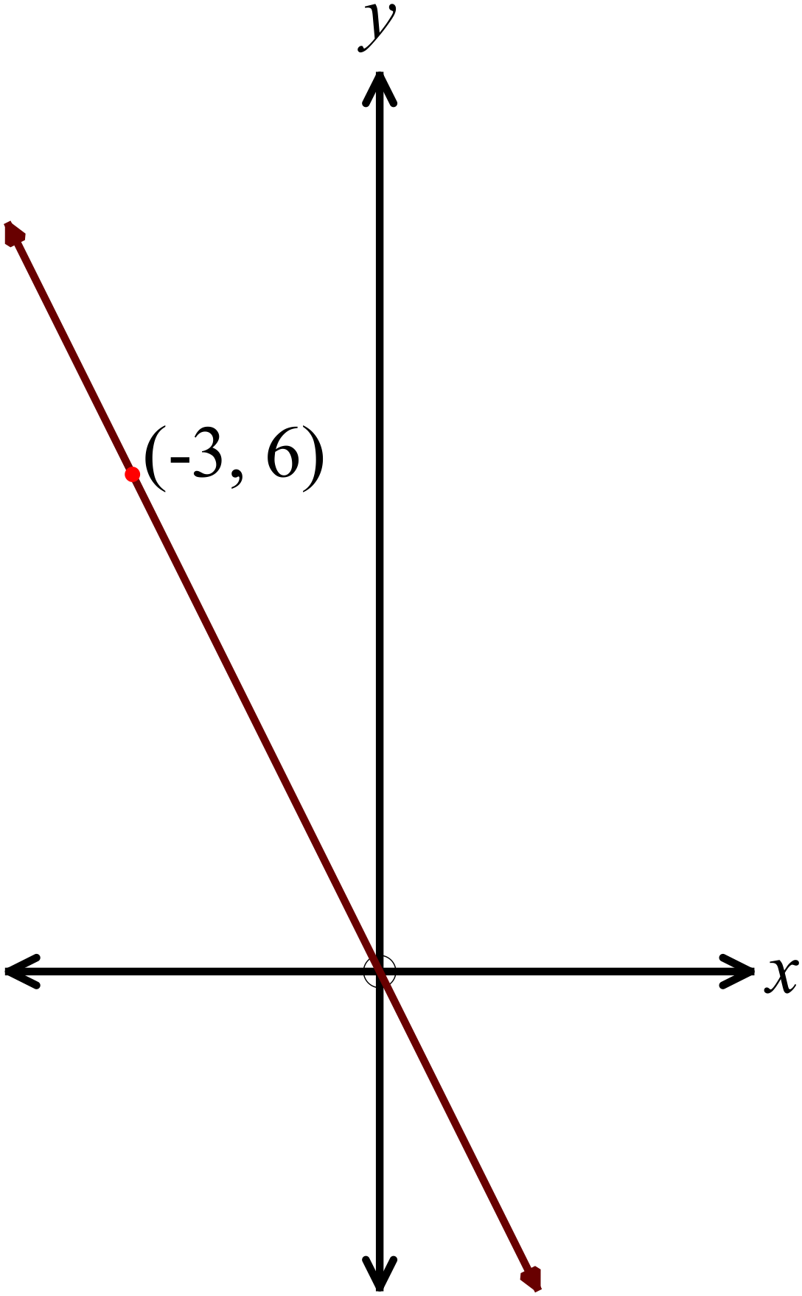What is the equation of the line shown?

…………………………………………

………………………………………….

…………………………………………

………………………………………………………………………………………………………

………………………………………………………………………………………………………
A line on the number plane has a gradient of 6 and crosses the y axis at y = 7.

What is the equation of the line?

………………………………………………………………………………………………………

………………………………………………………………………………………………………
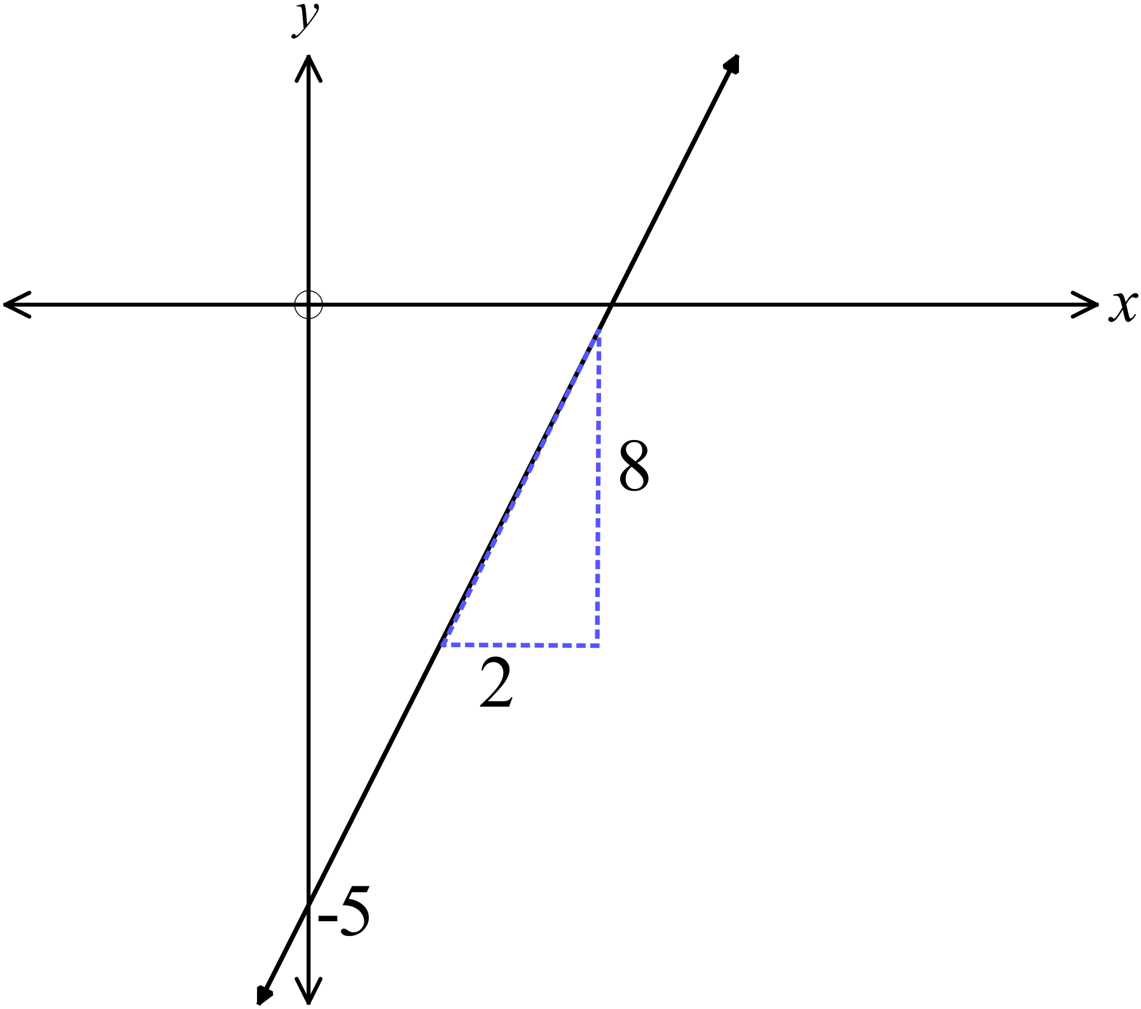What is the equation of the line shown?
.....................................................................

.....................................................................

.....................................................................

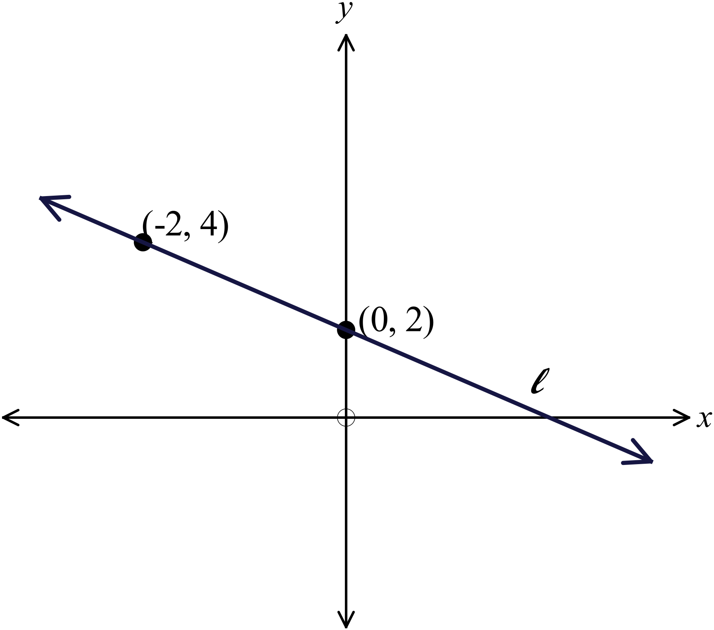The points (0, 2) and (-2, 4) lie on a line l.
What is the equation of the line l ?
.....................................................................

.....................................................................

.....................................................................

.....................................................................
On a number plane, a straight line has a gradient of 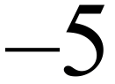 and passes through the point (-3, -6).
What is the equation of the line?

……………………………………………………………………………………………….

……………………………………………………………………………………………….
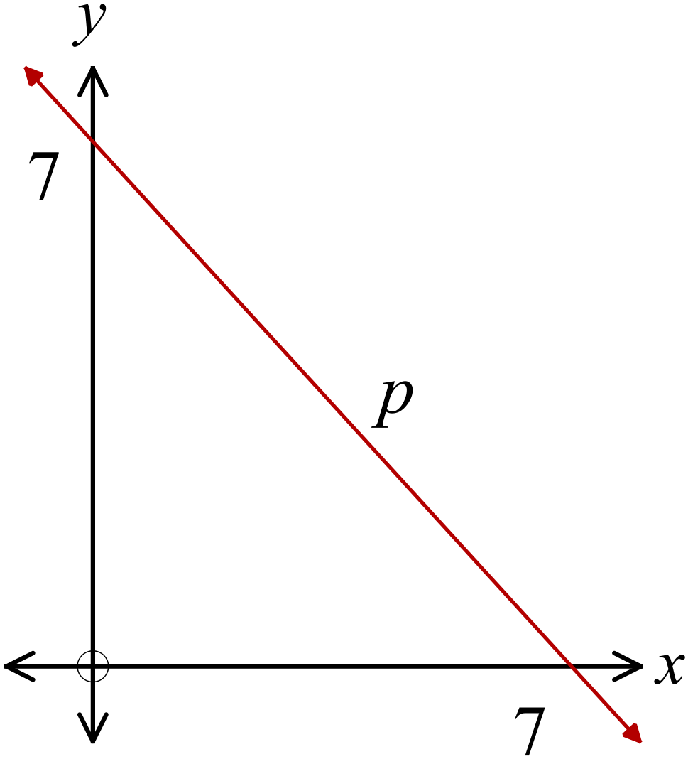The line p is shown on the number plane to the right.
The equation of the line p, is:

…………………………………………

………………………………………….

…………………………………………
A line on the number plane crosses the x axis at 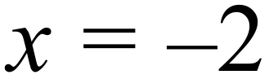 and crosses the y axis at 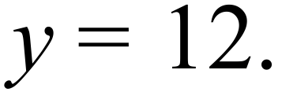
What is the equation of the line?

………………………………………………………………………………………………………

………………………………………………………………………………………………………
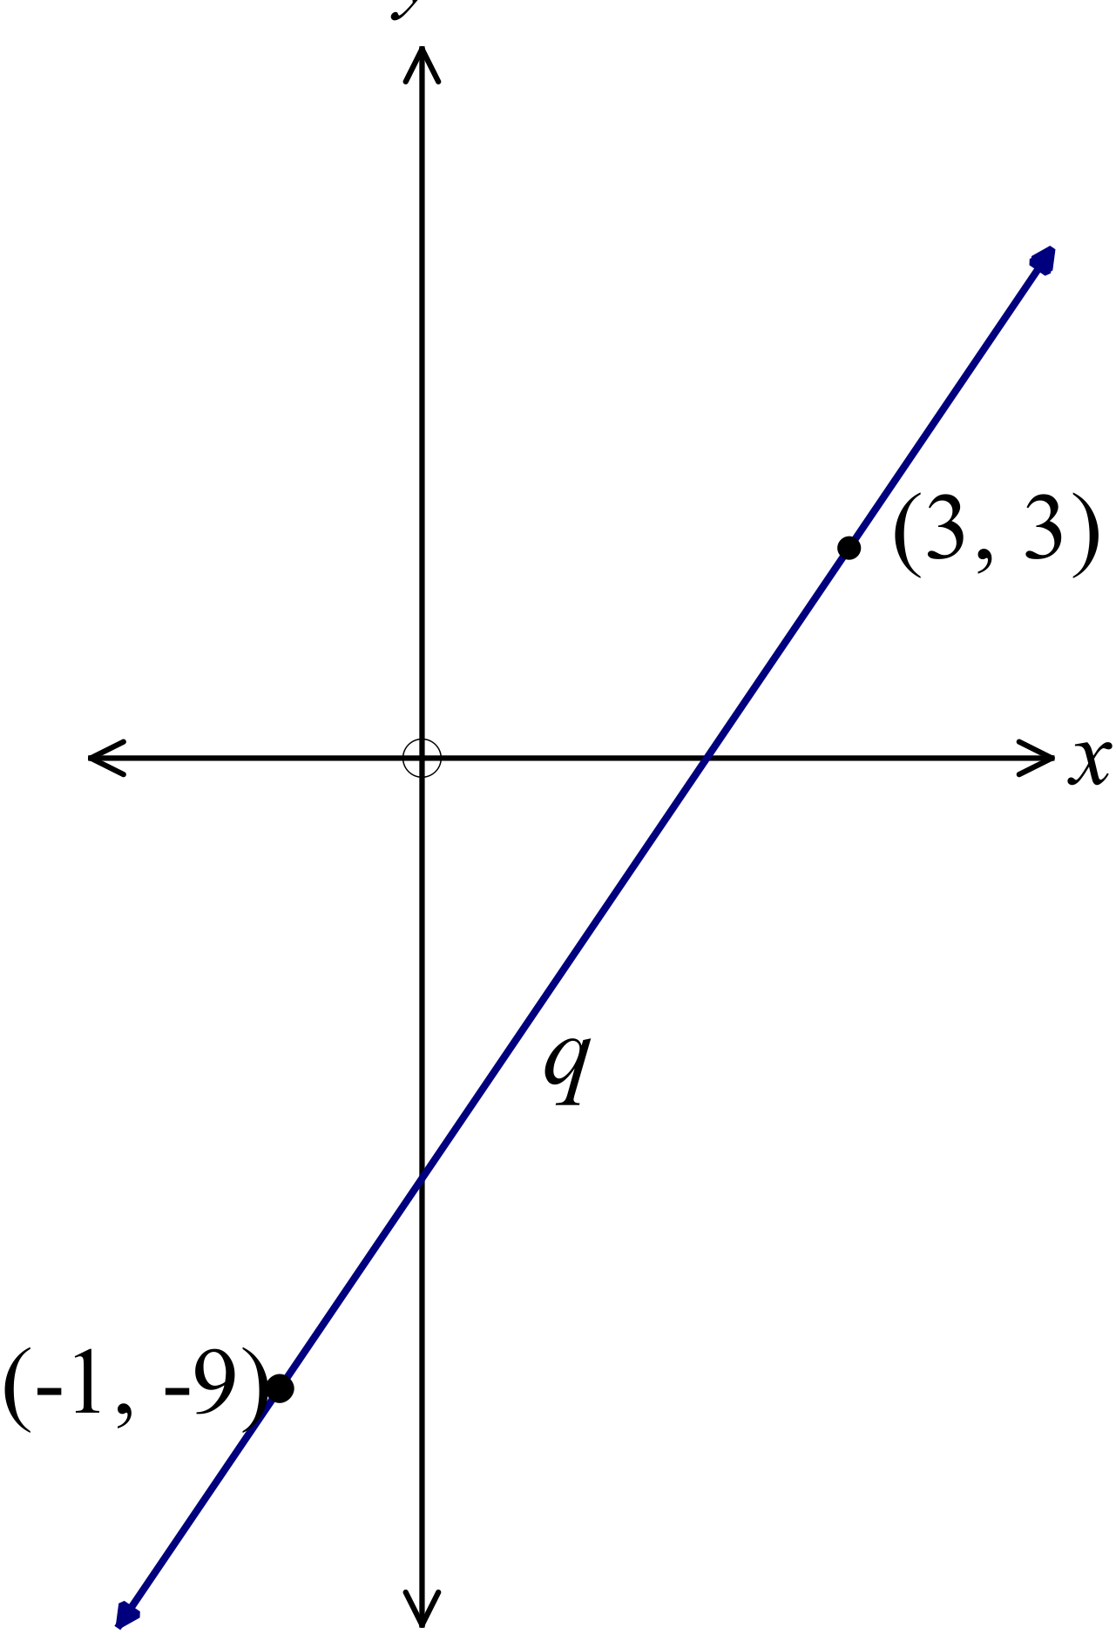The points 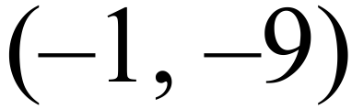 and (3, 3) lie on a line q.
What is the equation of the line q?

.....................................................................

.....................................................................

.....................................................................

.....................................................................
A straight line on a number plane has an equation of 
What is the gradient of the line?

……………………………………………………………………………………………….

……………………………………………………………………………………………….
A line on the Cartesian plane is parallel to the line 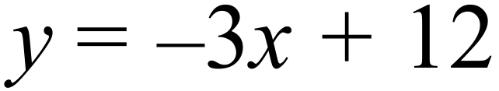 and passes through the point 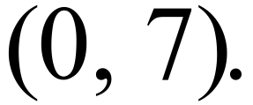
What is the equation of the line?

……………………………………………………………………………………………….

……………………………………………………………………………………………….
A straight line on a number plane is parallel to the line 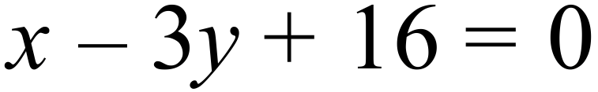 and passes through (2, 12).
What is the equation of the line?

……………………………………………………………………………………………….

……………………………………………………………………………………………….
are perpendicular and intersect at the point (-2, -4).
Find the equation of the line j.

……………………………………………………………………………………………….

……………………………………………………………………………………………….

Year 10 |  | Linear Relations | Calculator Allowed
 |  | Linear Relations | Name_________________
Section 2 Multiple Choice Section
Mark all your answers on the accompanying multiple choice answer sheet, not on this test paper. You may do any working out on this test paper. Calculators are allowed for this section.

A line on the number plane has an equation: 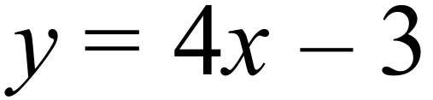.
What is its gradient?
A. 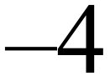 B. 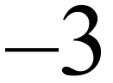 C. 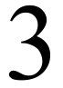 D. 4

 | 0 | 1 | 2 | 3
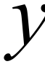 | 3 | 7 | 10 | 15

A. 3 B. 7 C. 10 D. 15
A line has a gradient of and passes through the point 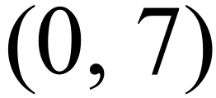 on the y axis.
What is its equation?
A. 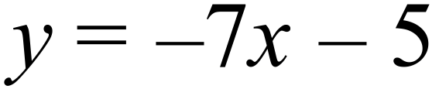
B. 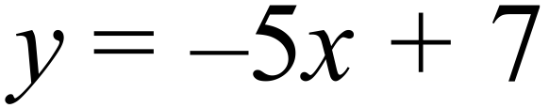
C. 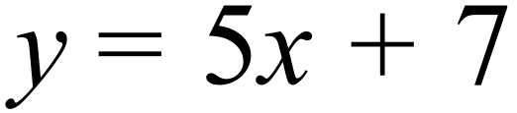
D. 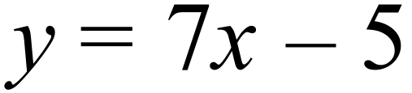
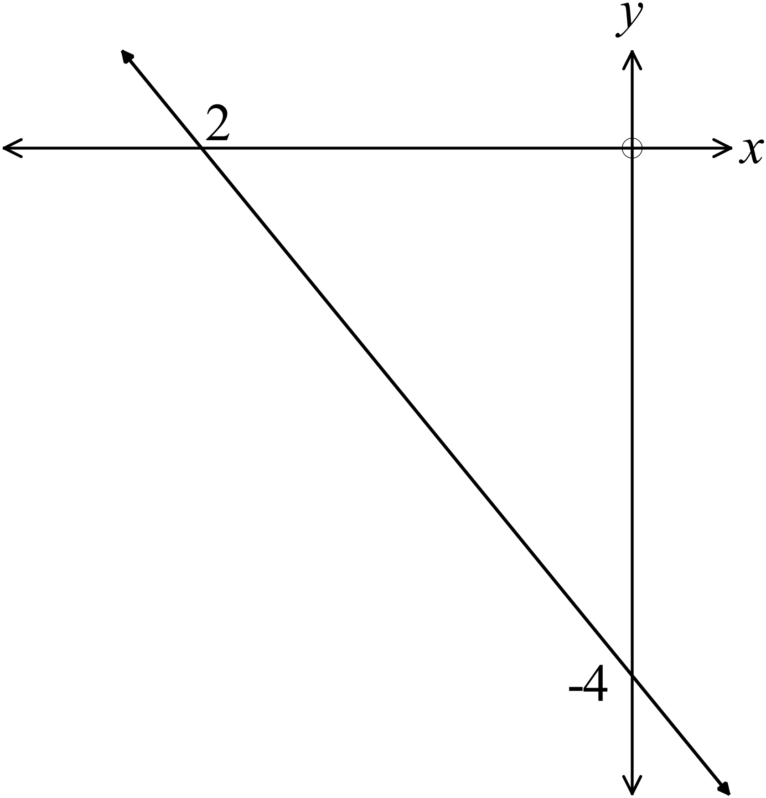The equation of the line shown is:

A. 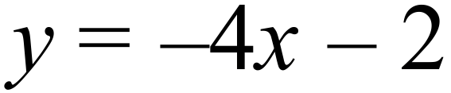

B. 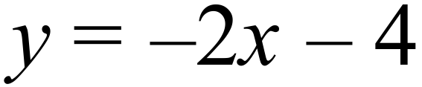

C. 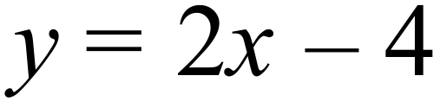

D. 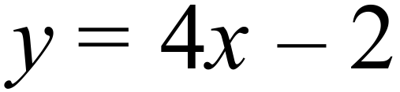

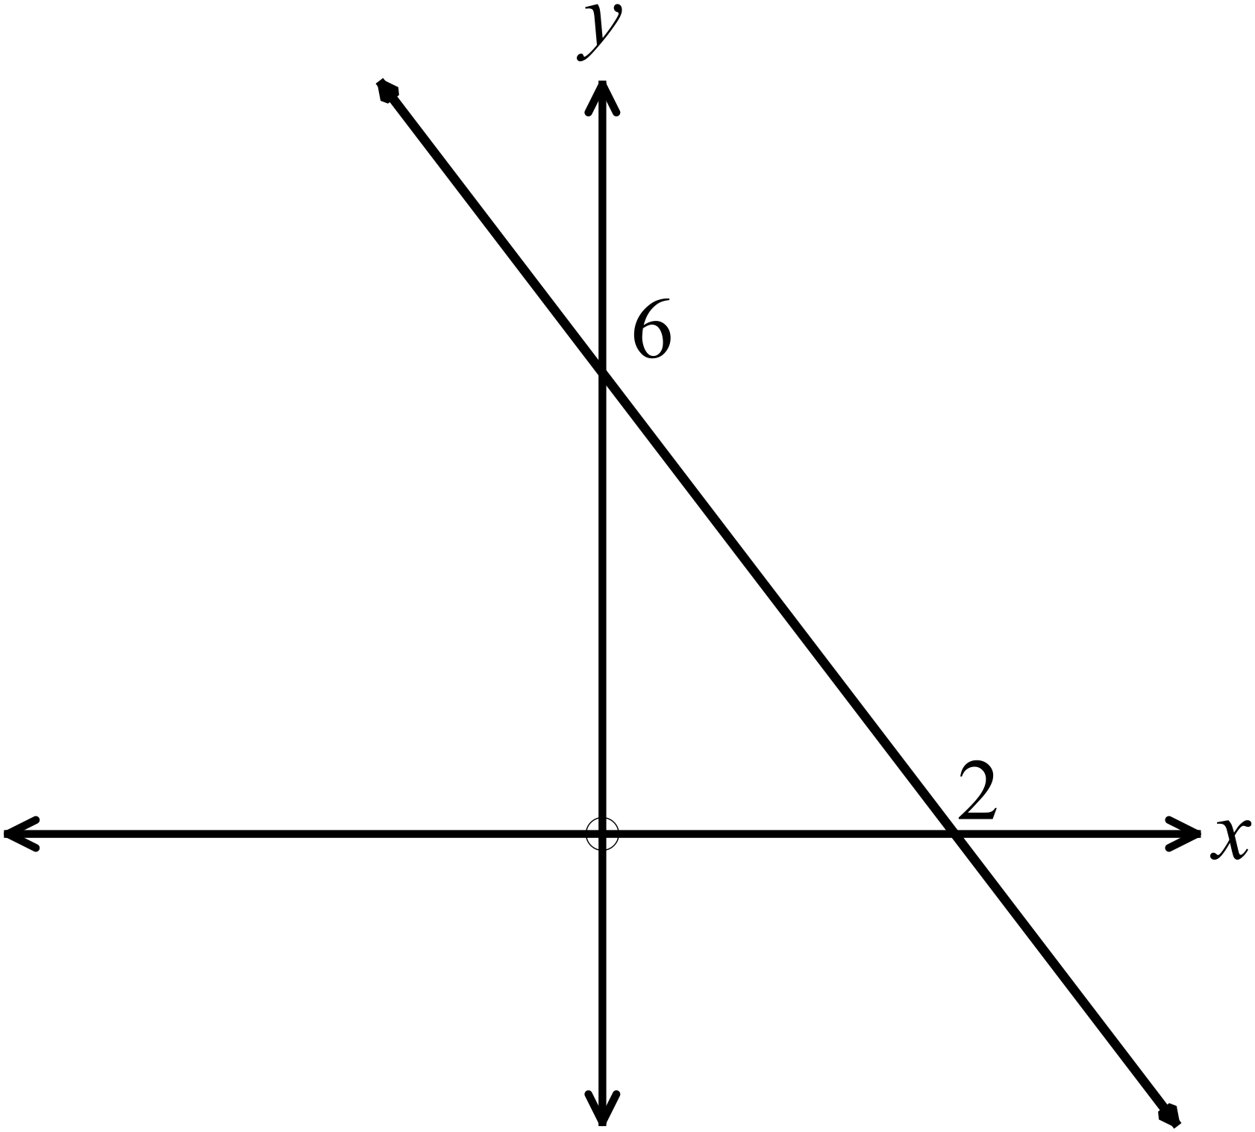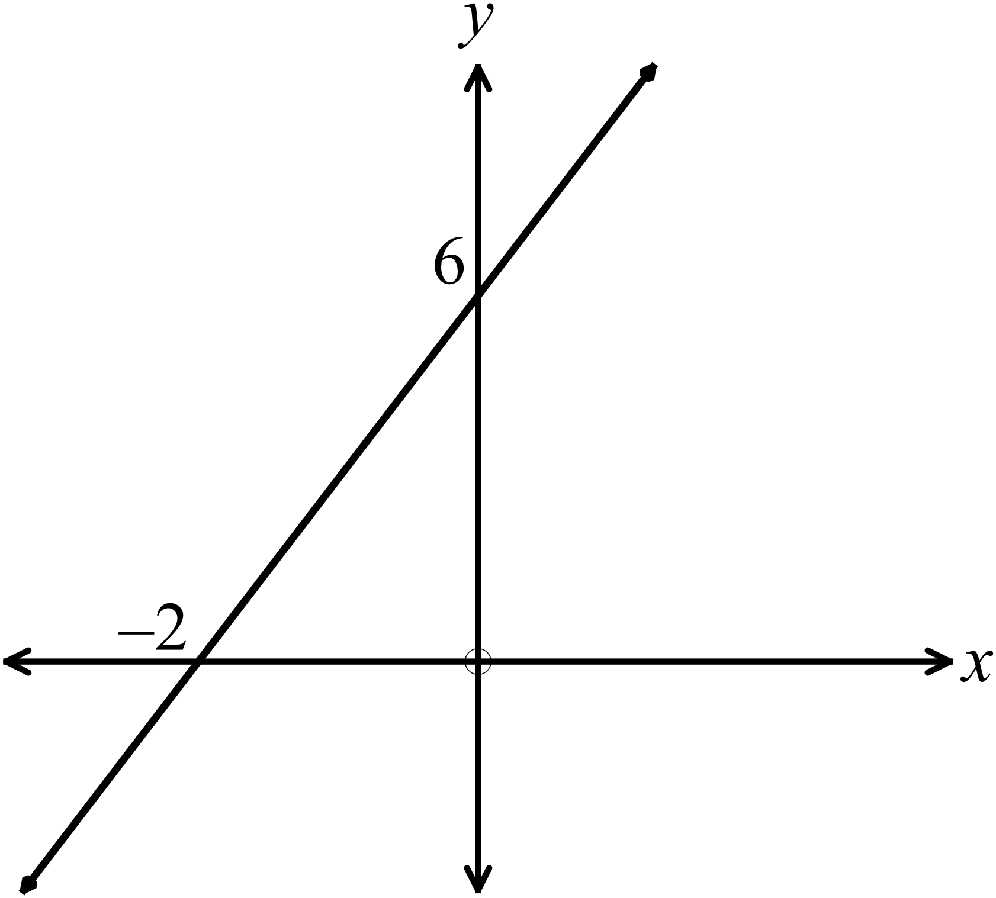 A. B.

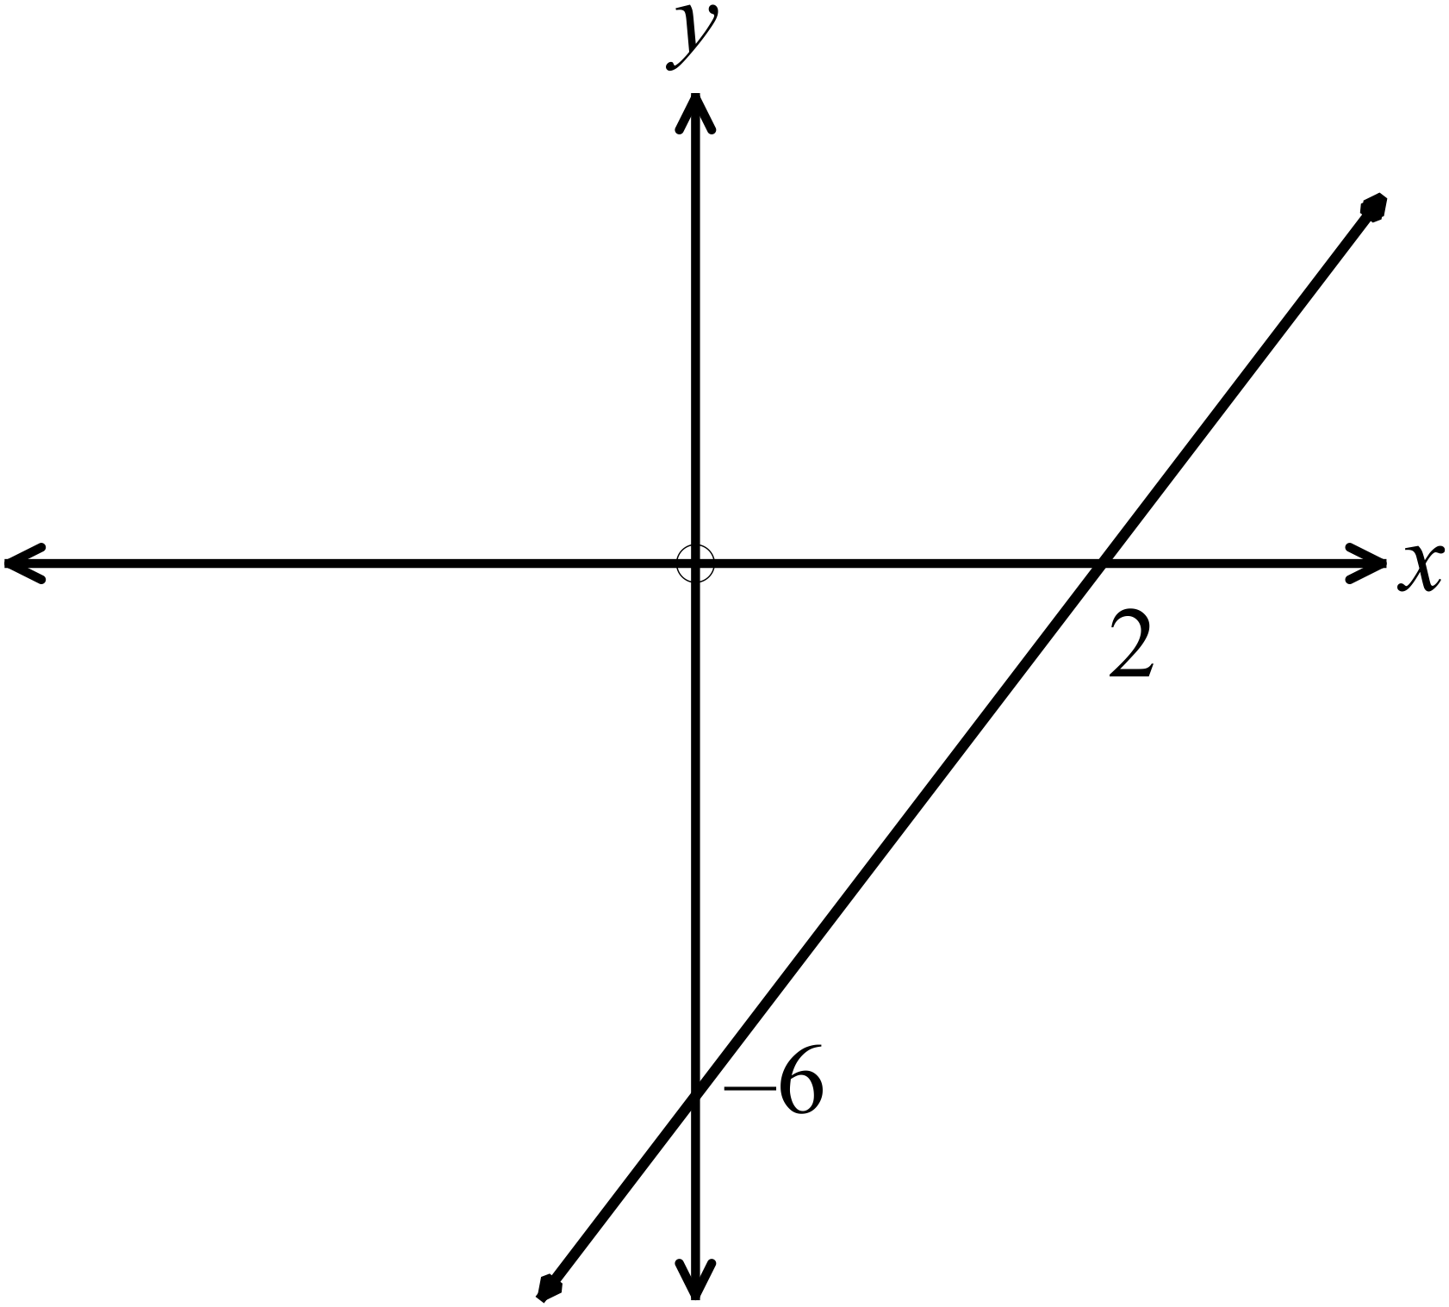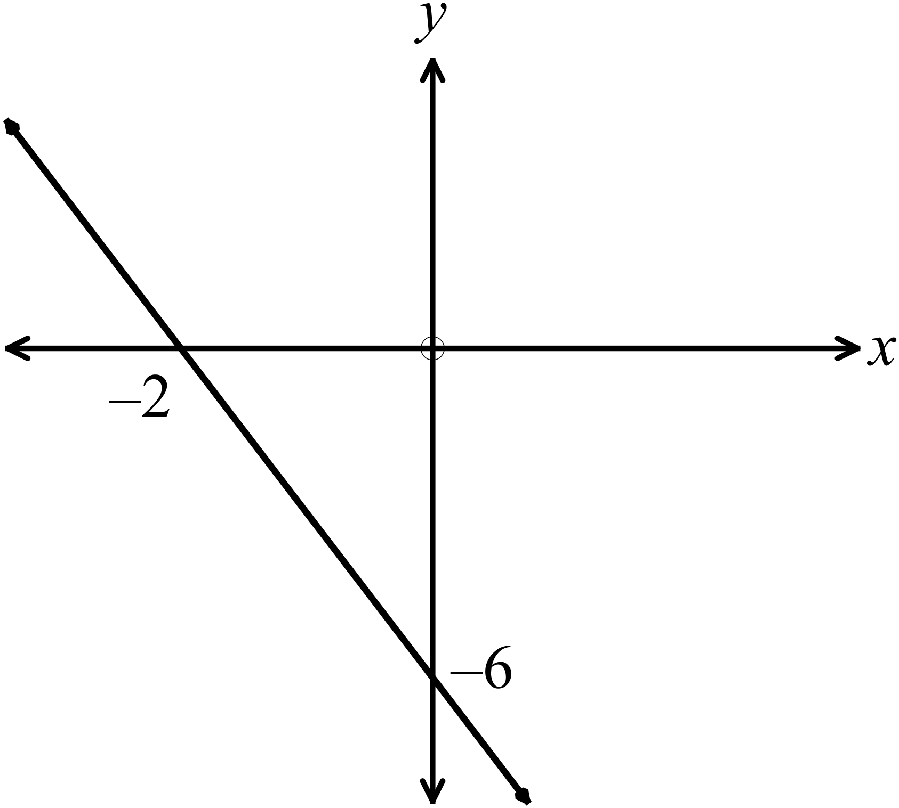 C. D.

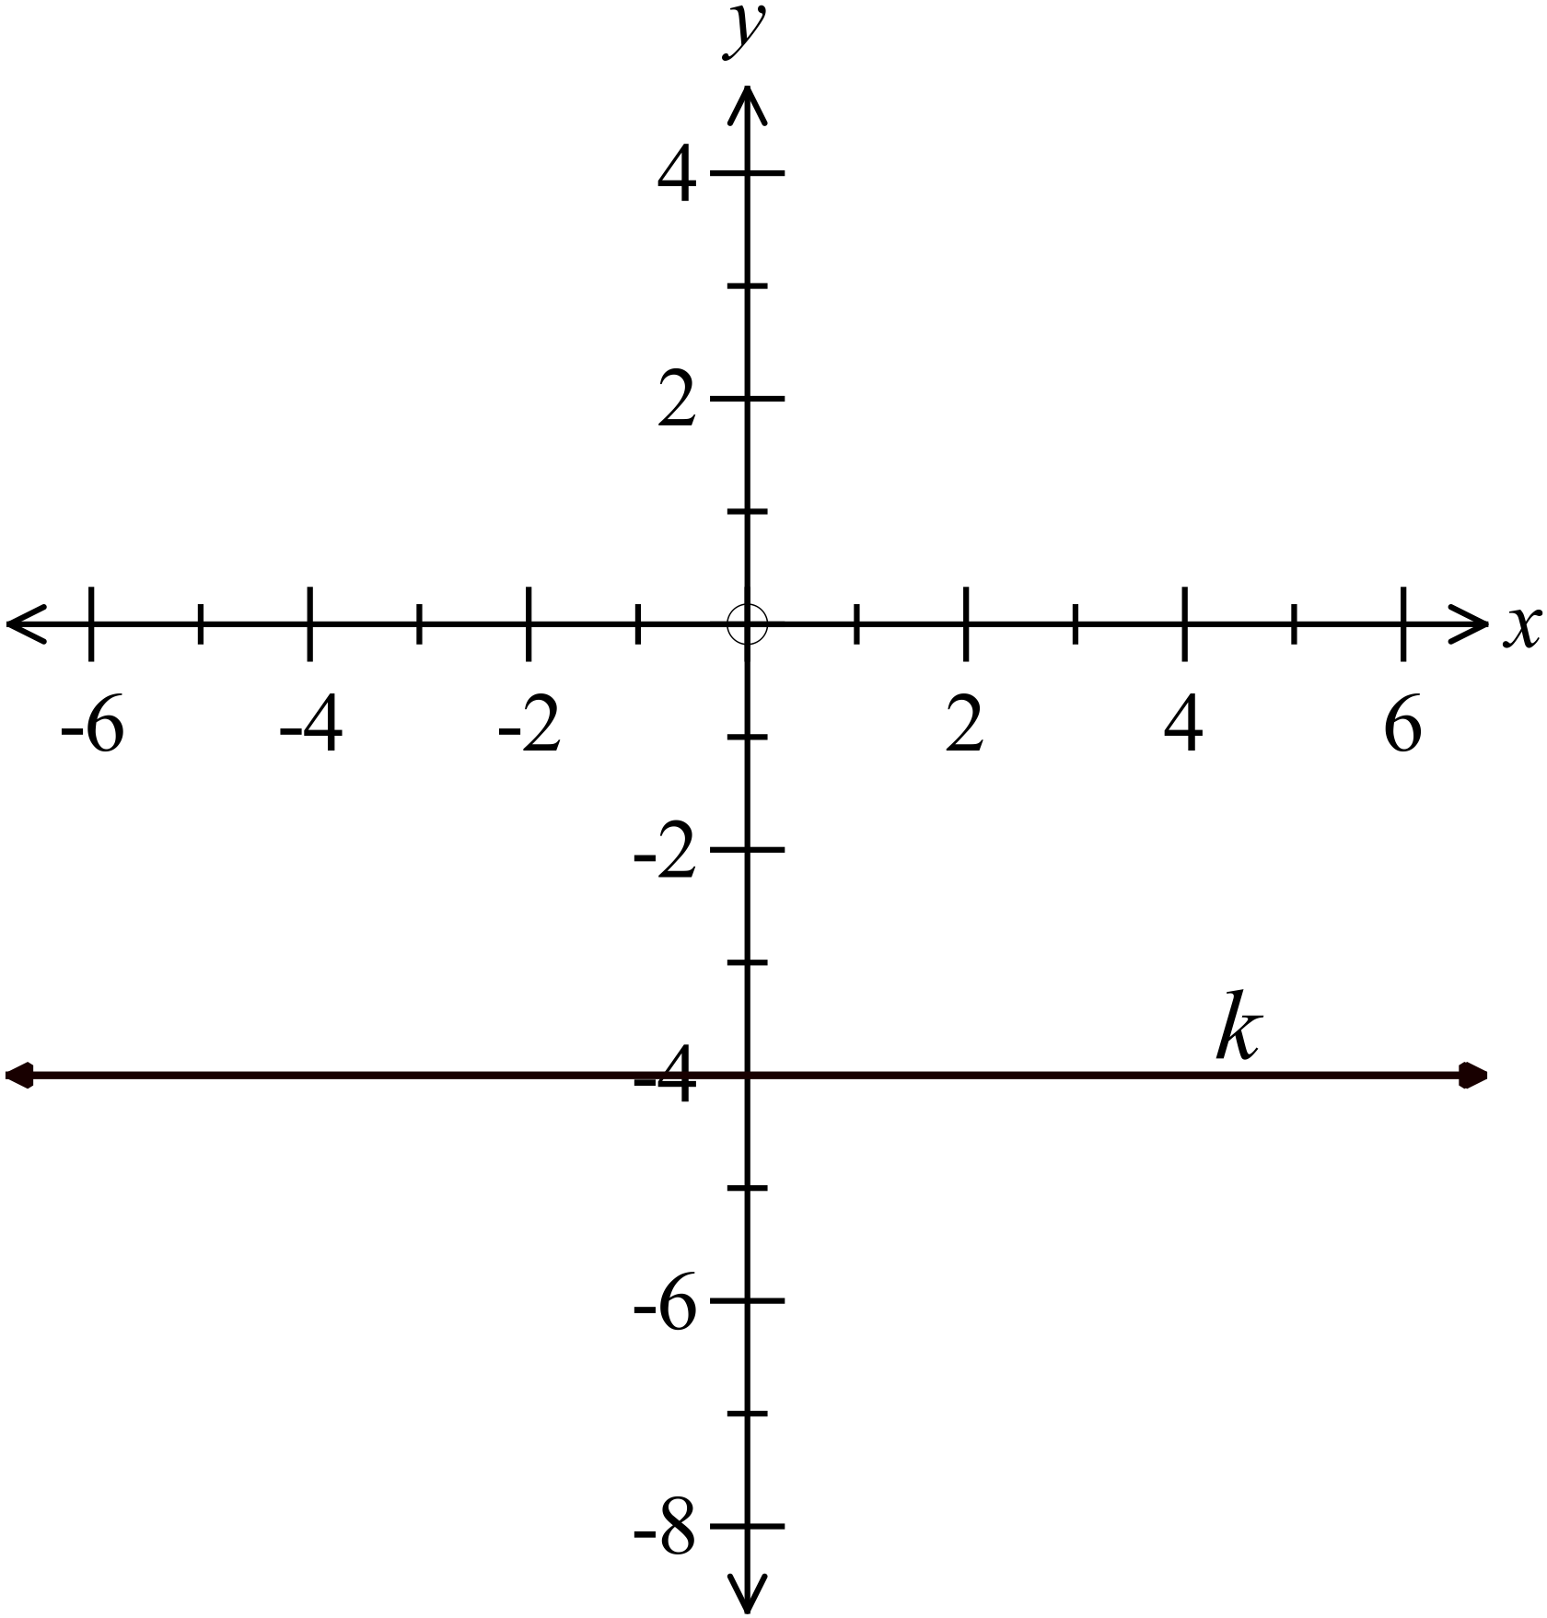The line k is shown on the number plane to the right.
The equation of the line k, is:

A. 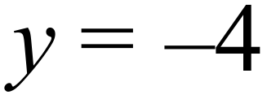
B. 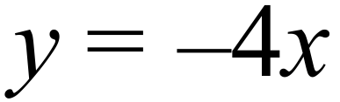
C. 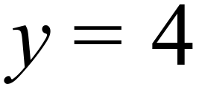
D. 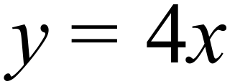

A line has a gradient of 4 and passes through the point 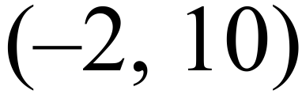 . What is its equation?

A. 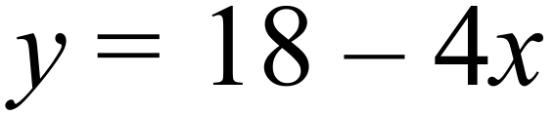

B. 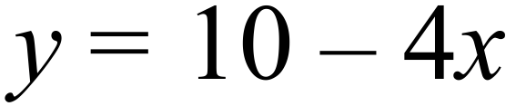

C. 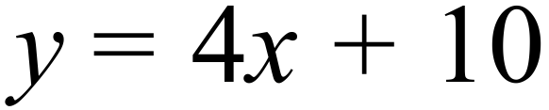

D. 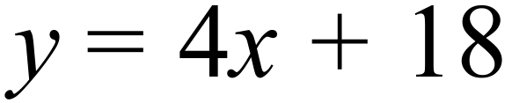

A line has an equation 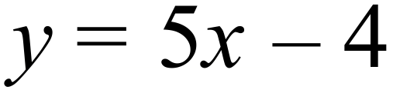.

Which point lies on the line?

A. (-2, -7) B. (-2, -14) C. (-1, -8) D. (-1, -10)

Which is the graph of the line 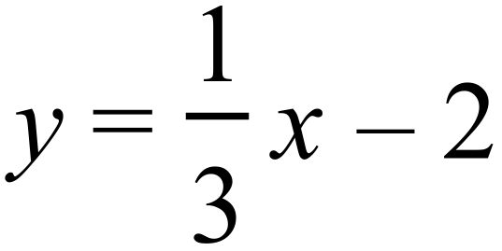 ?
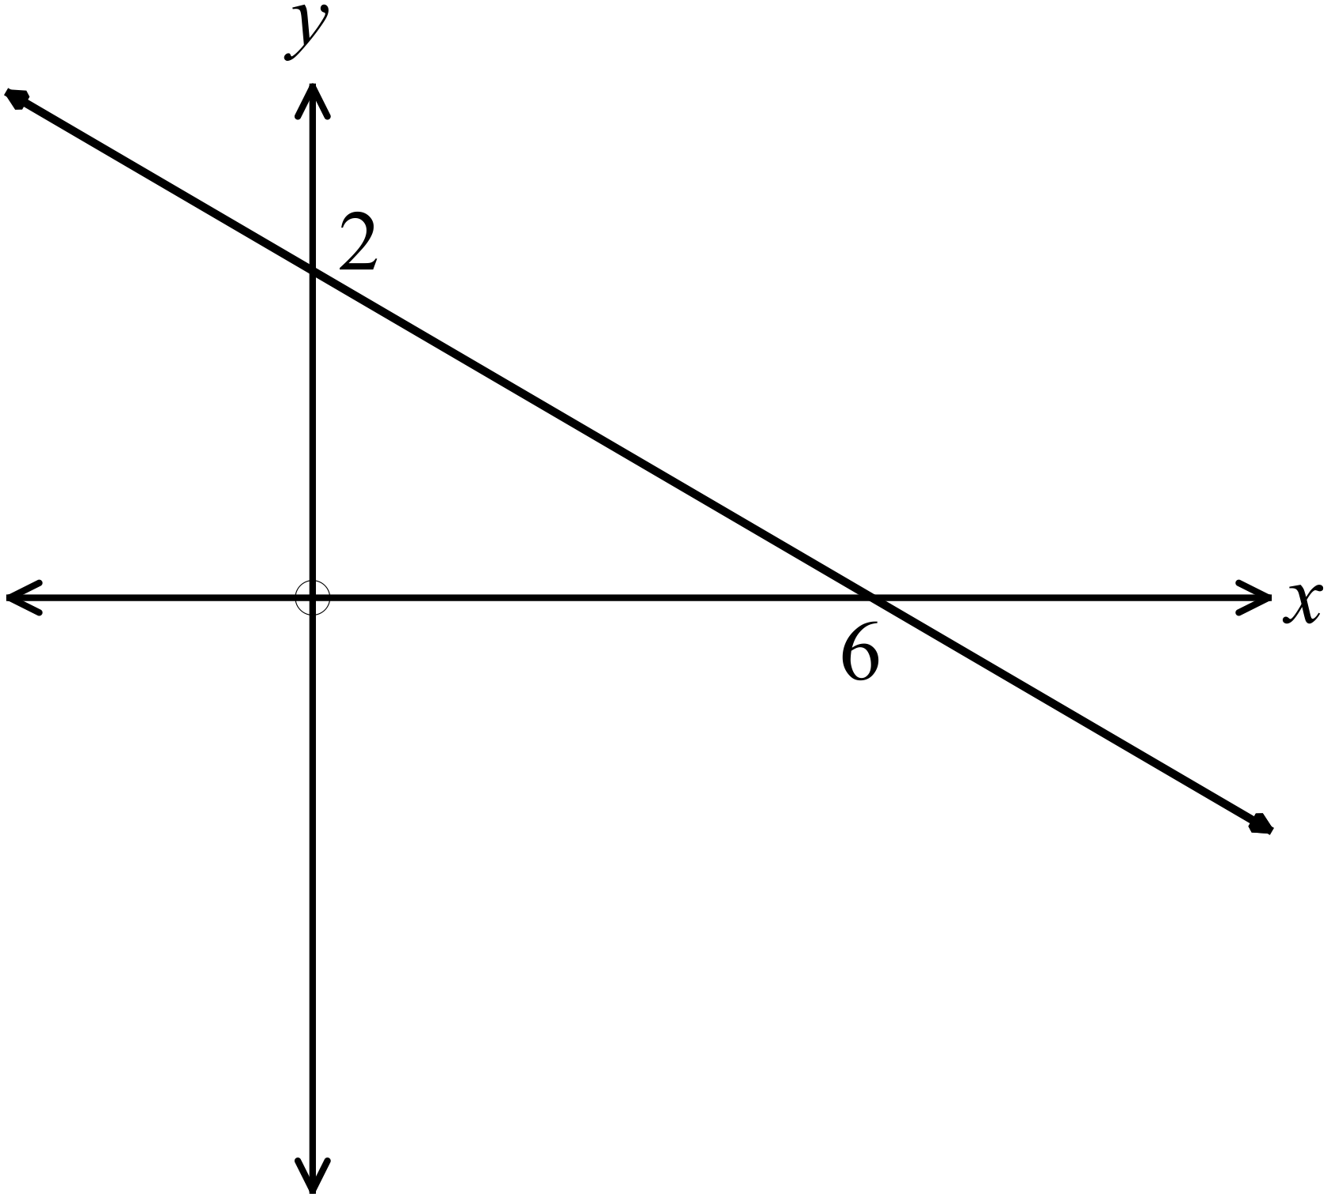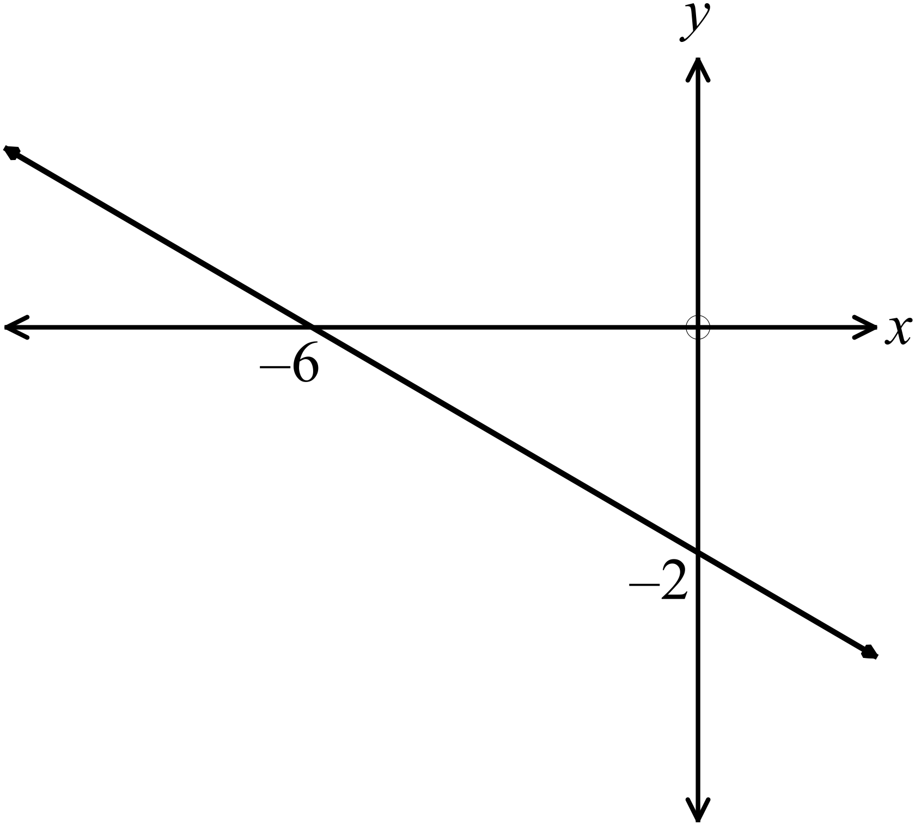
A. B.

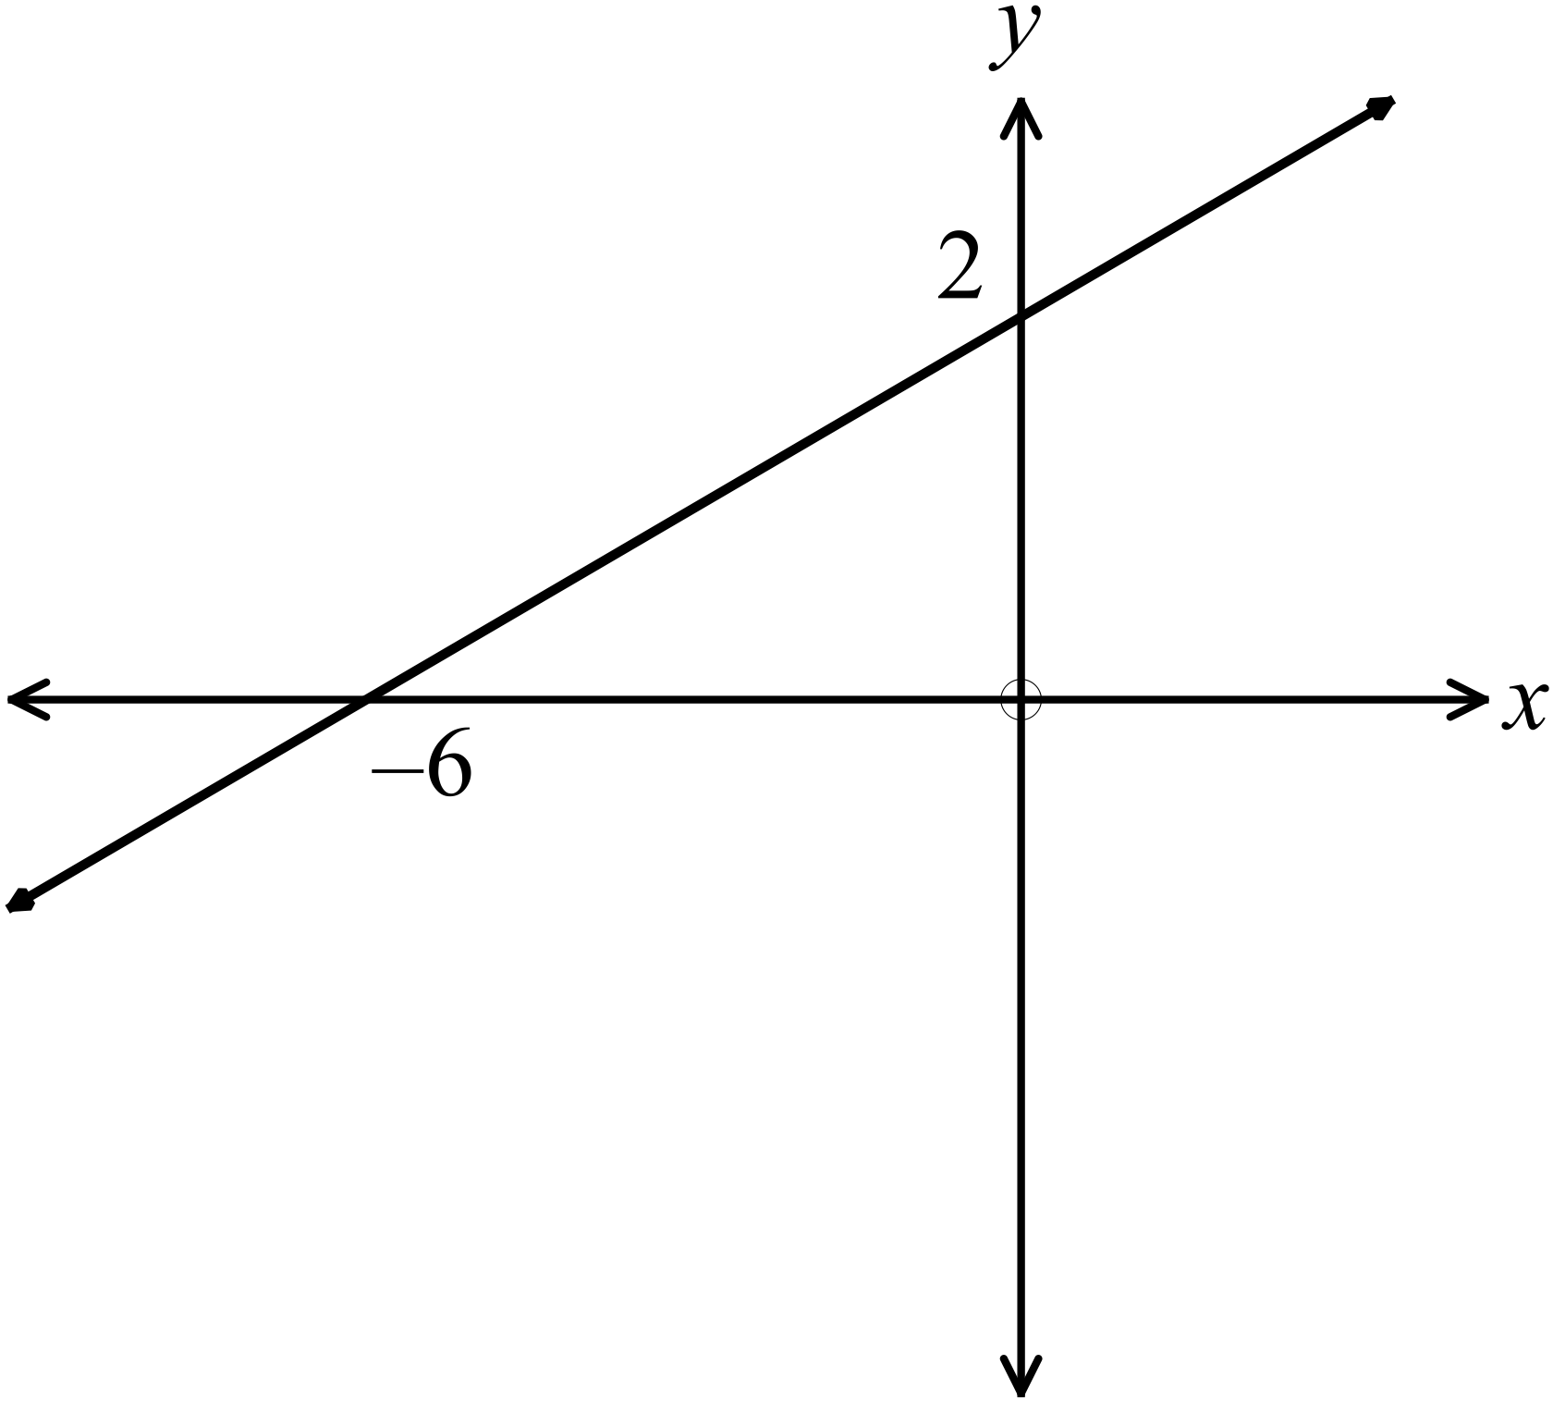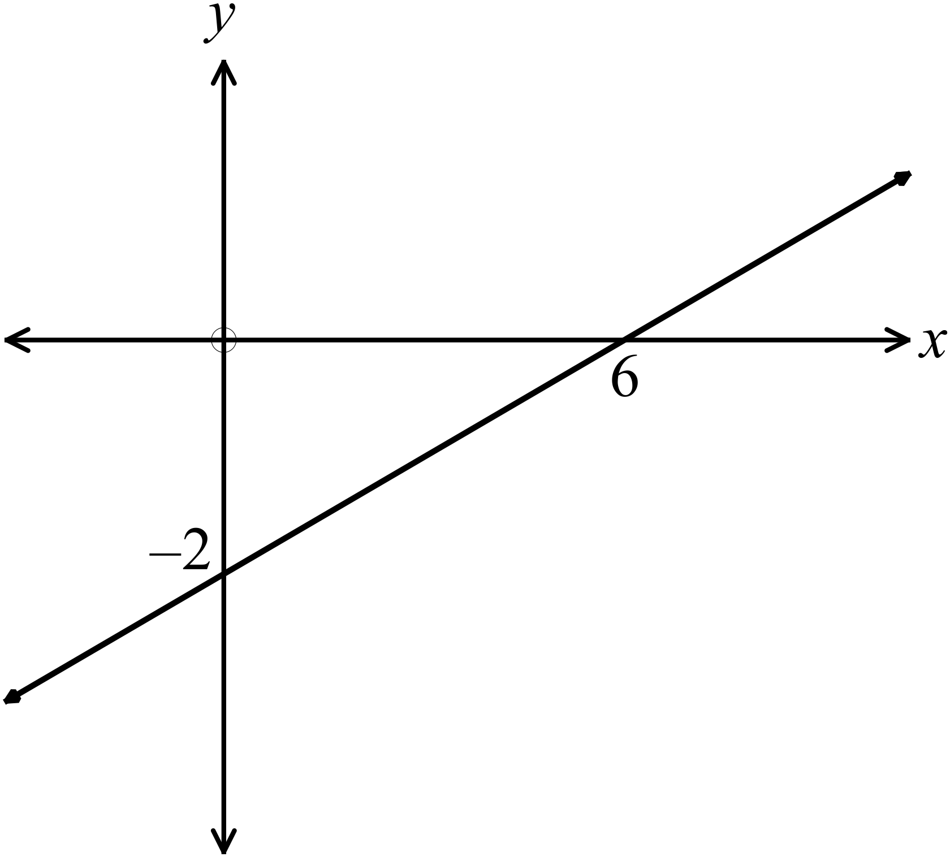 C. D.

A line has a gradient of and passes through the point 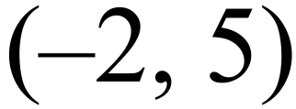.
What is its equation?

A. 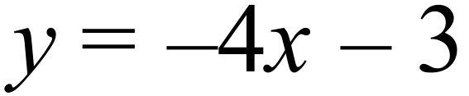 B. 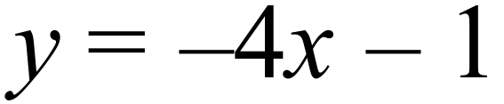 C. 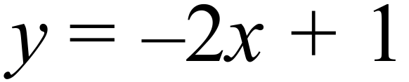 D. 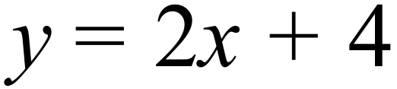
A line has equation 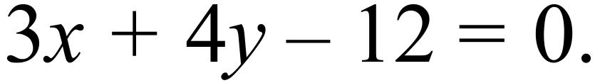 Which statement is true?

A. Its gradient is 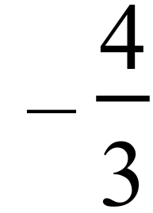 and its intercept is .
B. Its gradient is 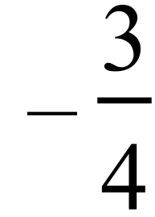 and its intercept is .
C. Its gradient is and its intercept is .
D. Its gradient is  and its intercept is
The points P 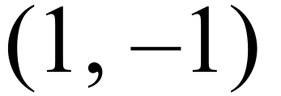 and Q 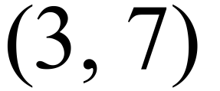 lie on a line l.

The equation of the line l , is:

A. 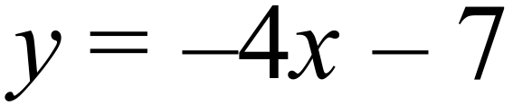 B. 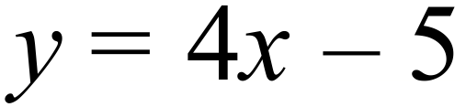 C. 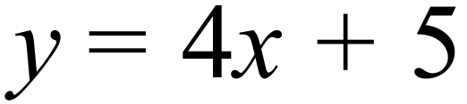 D. 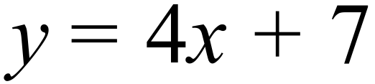
Line n has a gradient of 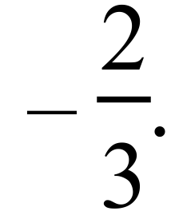
Line p has a gradient of 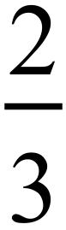.
Line q has a gradient of 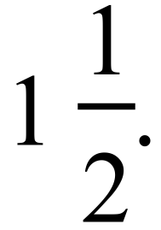

Which statement is true?

- Line n is perpendicular to line q.

- Line p is perpendicular to line q.

- Line p is perpendicular to line n.

- Line p is parallel to line n.

Which line is perpendicular to 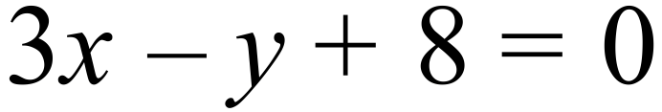

A. 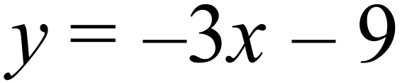 B. 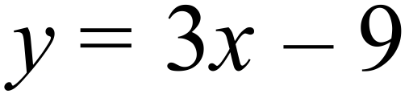 C. 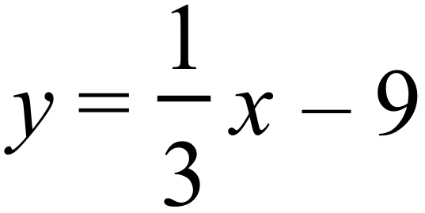 D. 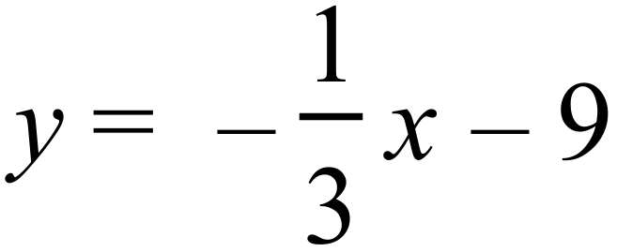
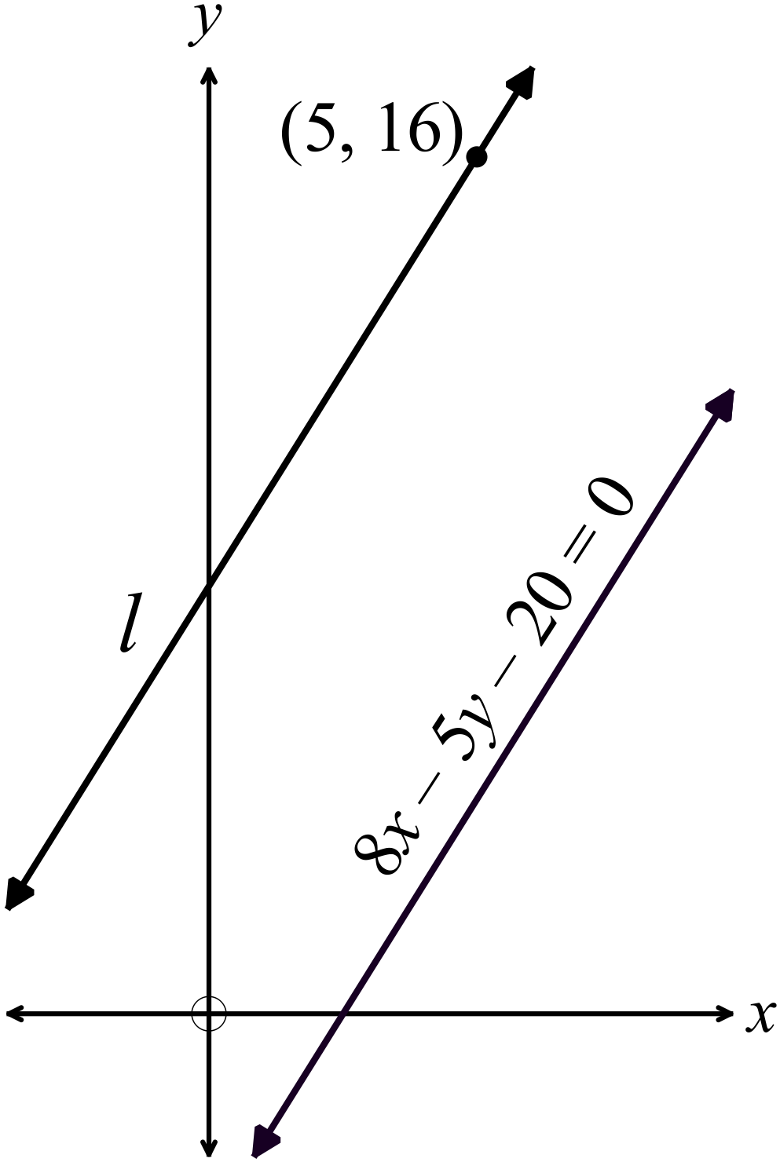The line l passes through the point (5, 16) and is parallel to the line 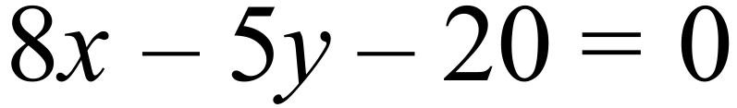.
What is the equation of the line l ?

A. 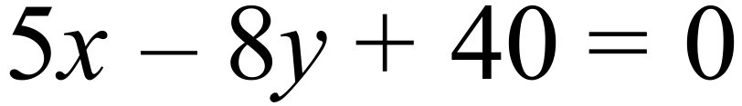

B. 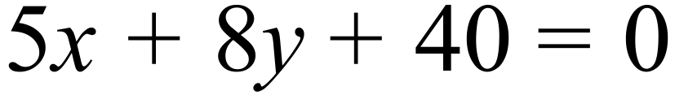

C. 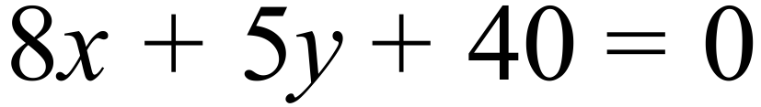

D. 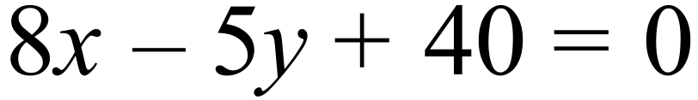

Multiple Choice Answer Sheet
Linear Relations
Name _____________________________________________
Completely fill the response oval representing the most correct answer.

1. A B C D
2. A B C D
3. A B C D
4. A B C D
5. A B C D
6. A B C D
7. A B C D
8. A B C D
9. A B C D
10. A B C D
11. A B C D
12. A B C D
13. A B C D
14. A B C D
15. A B C D
Year 10 |  | Linear Relations | Non Calculator
Section 1 Short Answer Section
ANSWERS
No. | WORKING |  | ANSWER
 | 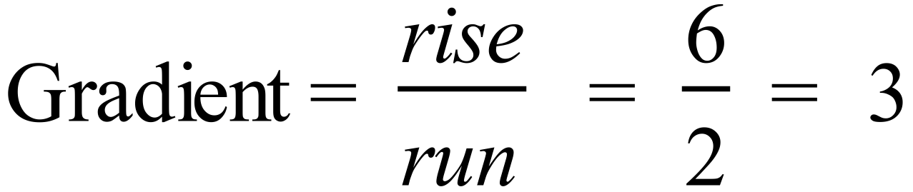 |  | 3
 |  |  | See table
   | 1 | 2 | 3 | 4
  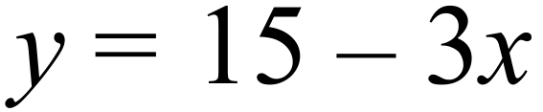 | 12 | 9 | 6 | 6
 | 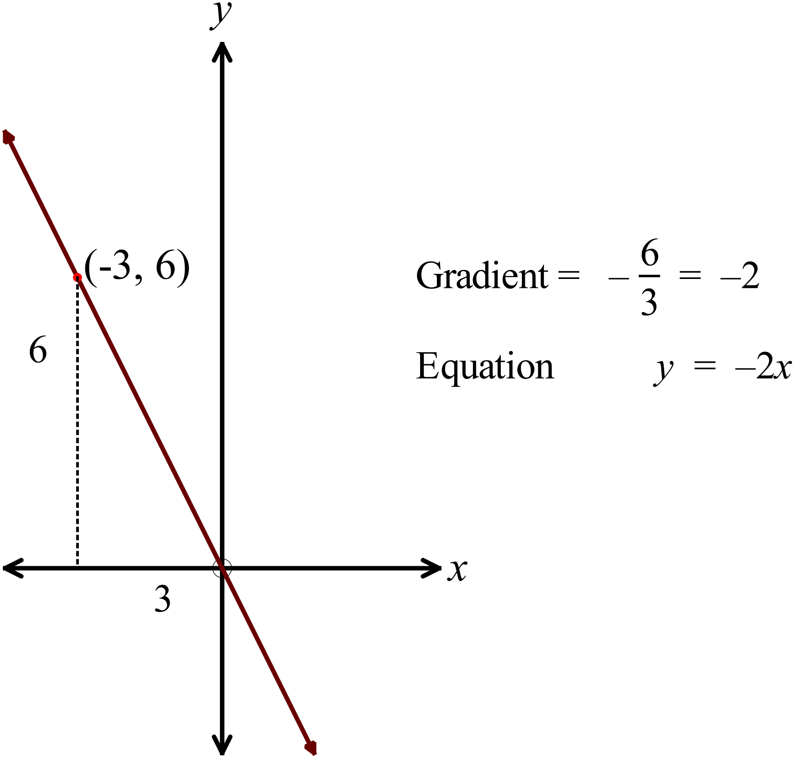 |  | 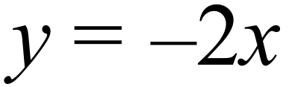
 | 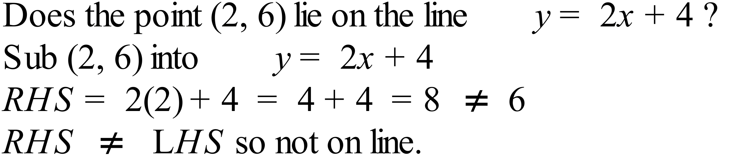 |  | Explanation why point is not on the line is needed for a mark.
 | Gradient m = 6 and y intercept b = 7.  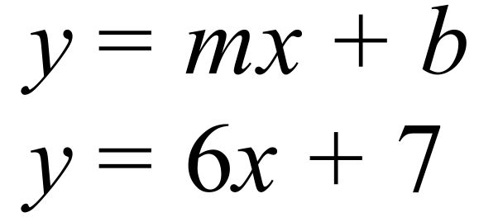 |  | 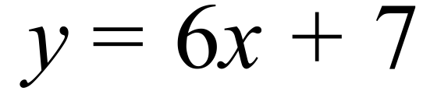
Gradient m = 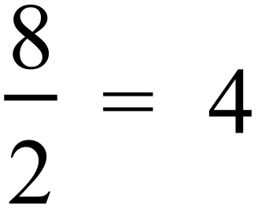 y intercept b = -5
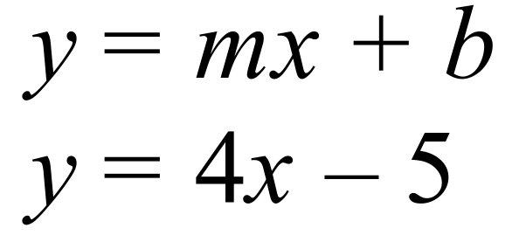
 | 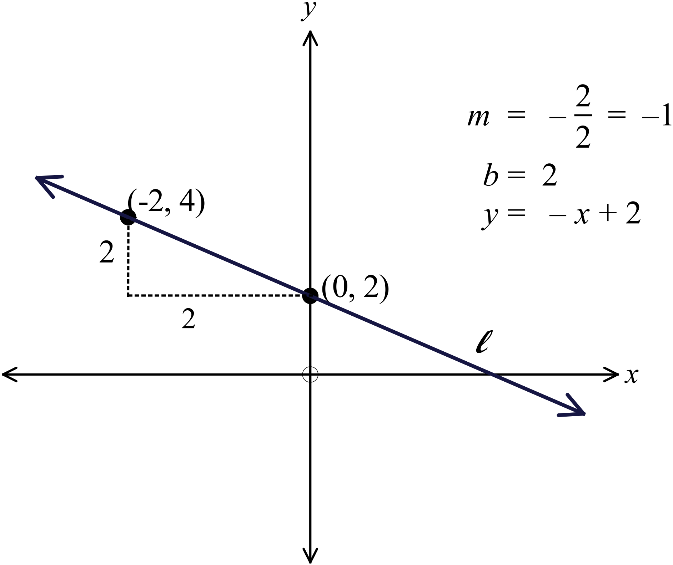 |  | 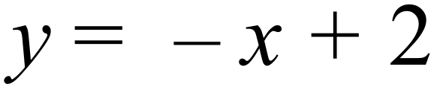
 | 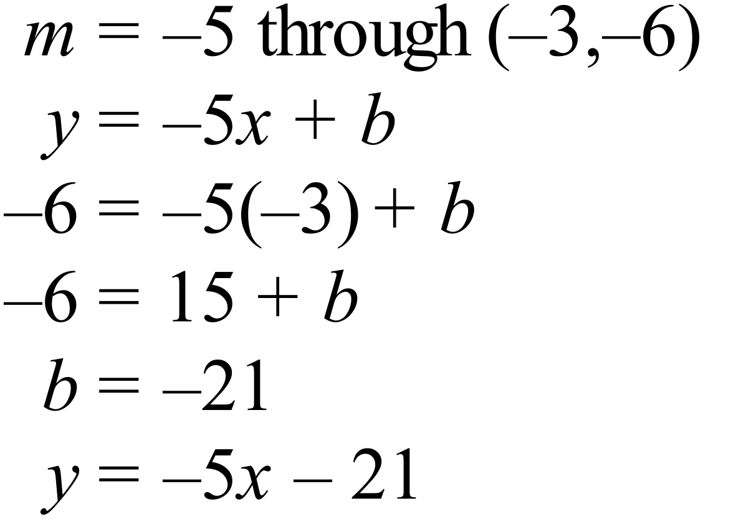 |  | 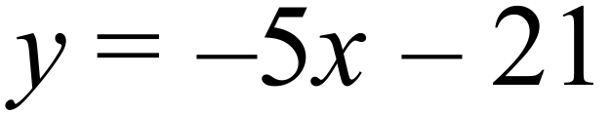
 | 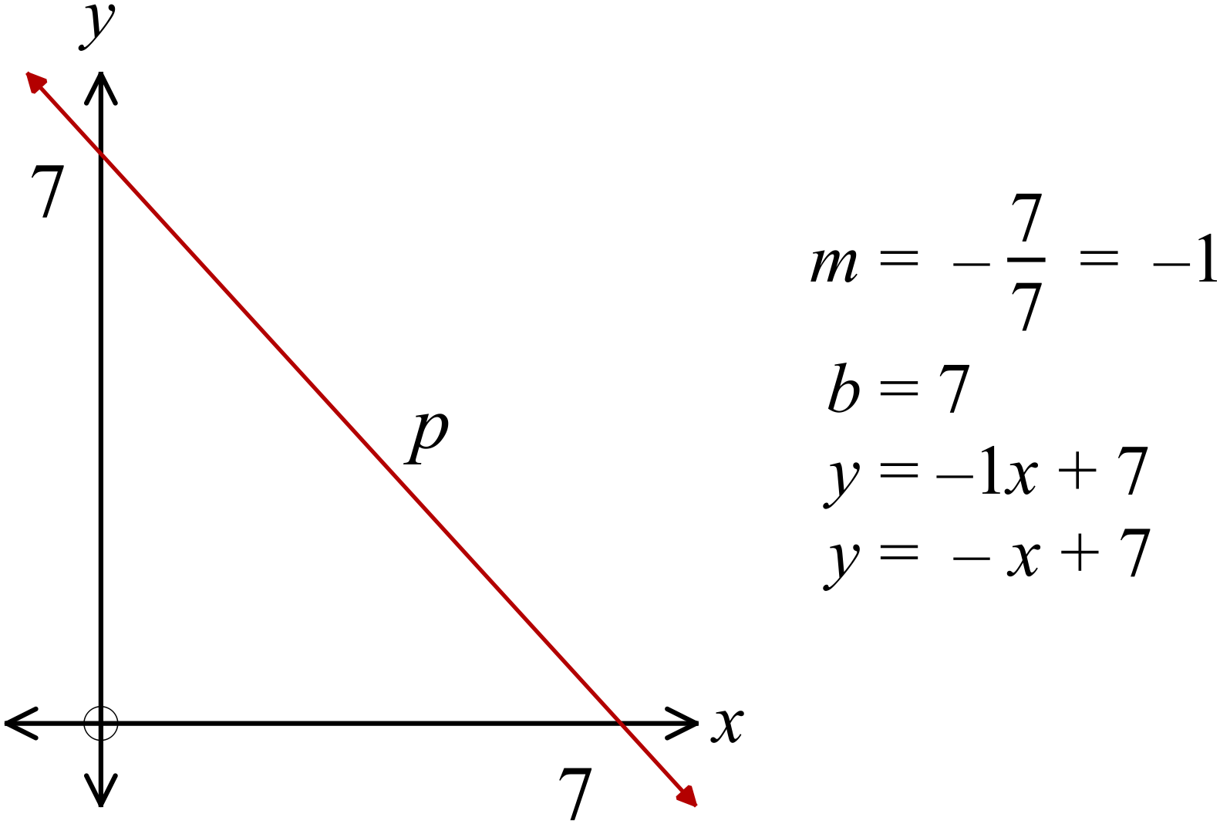 |  | 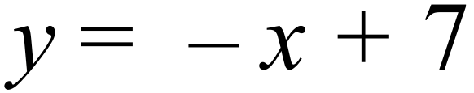
 | Crosses the x axis at and crosses the y axis at  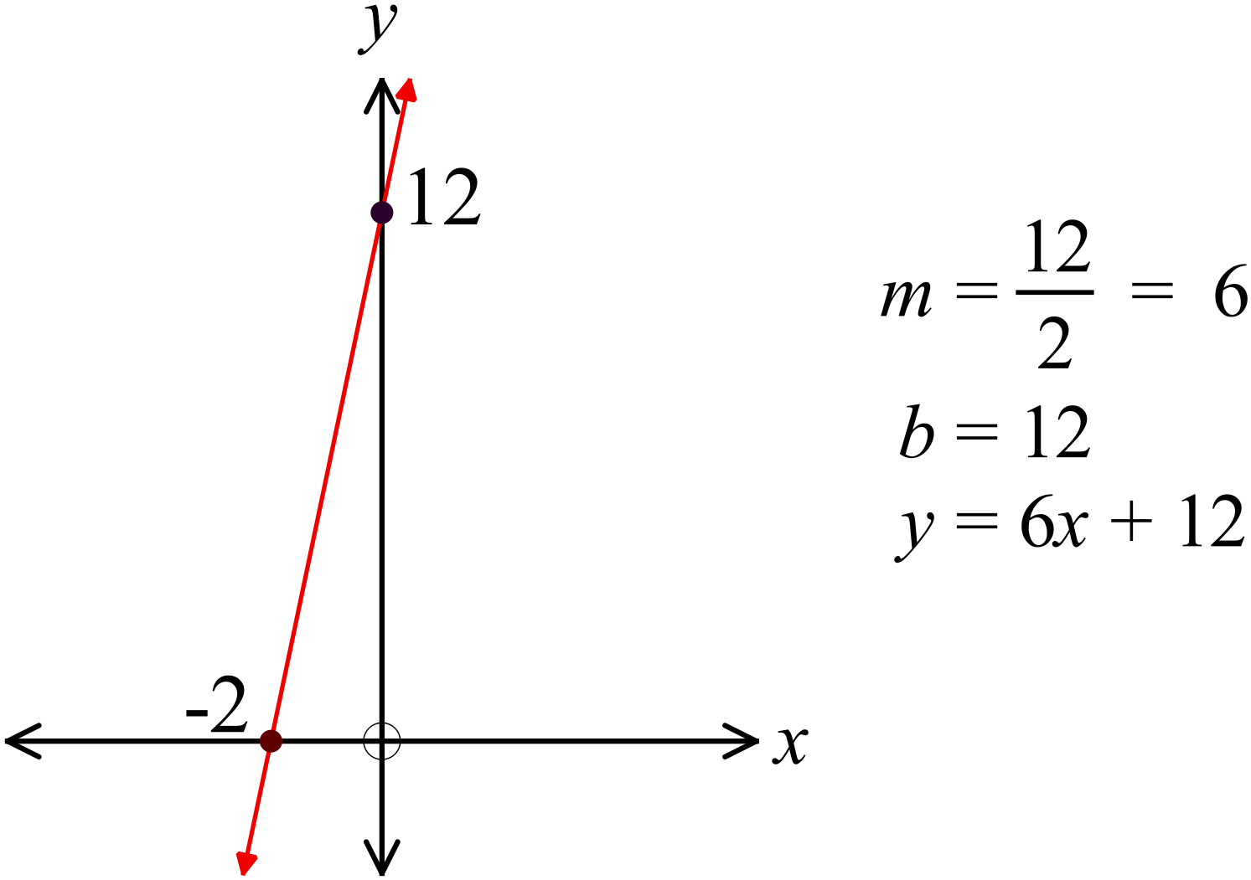 |  | 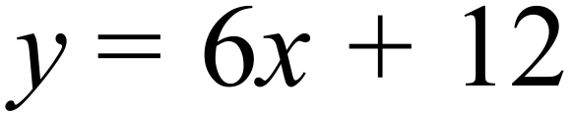
 | 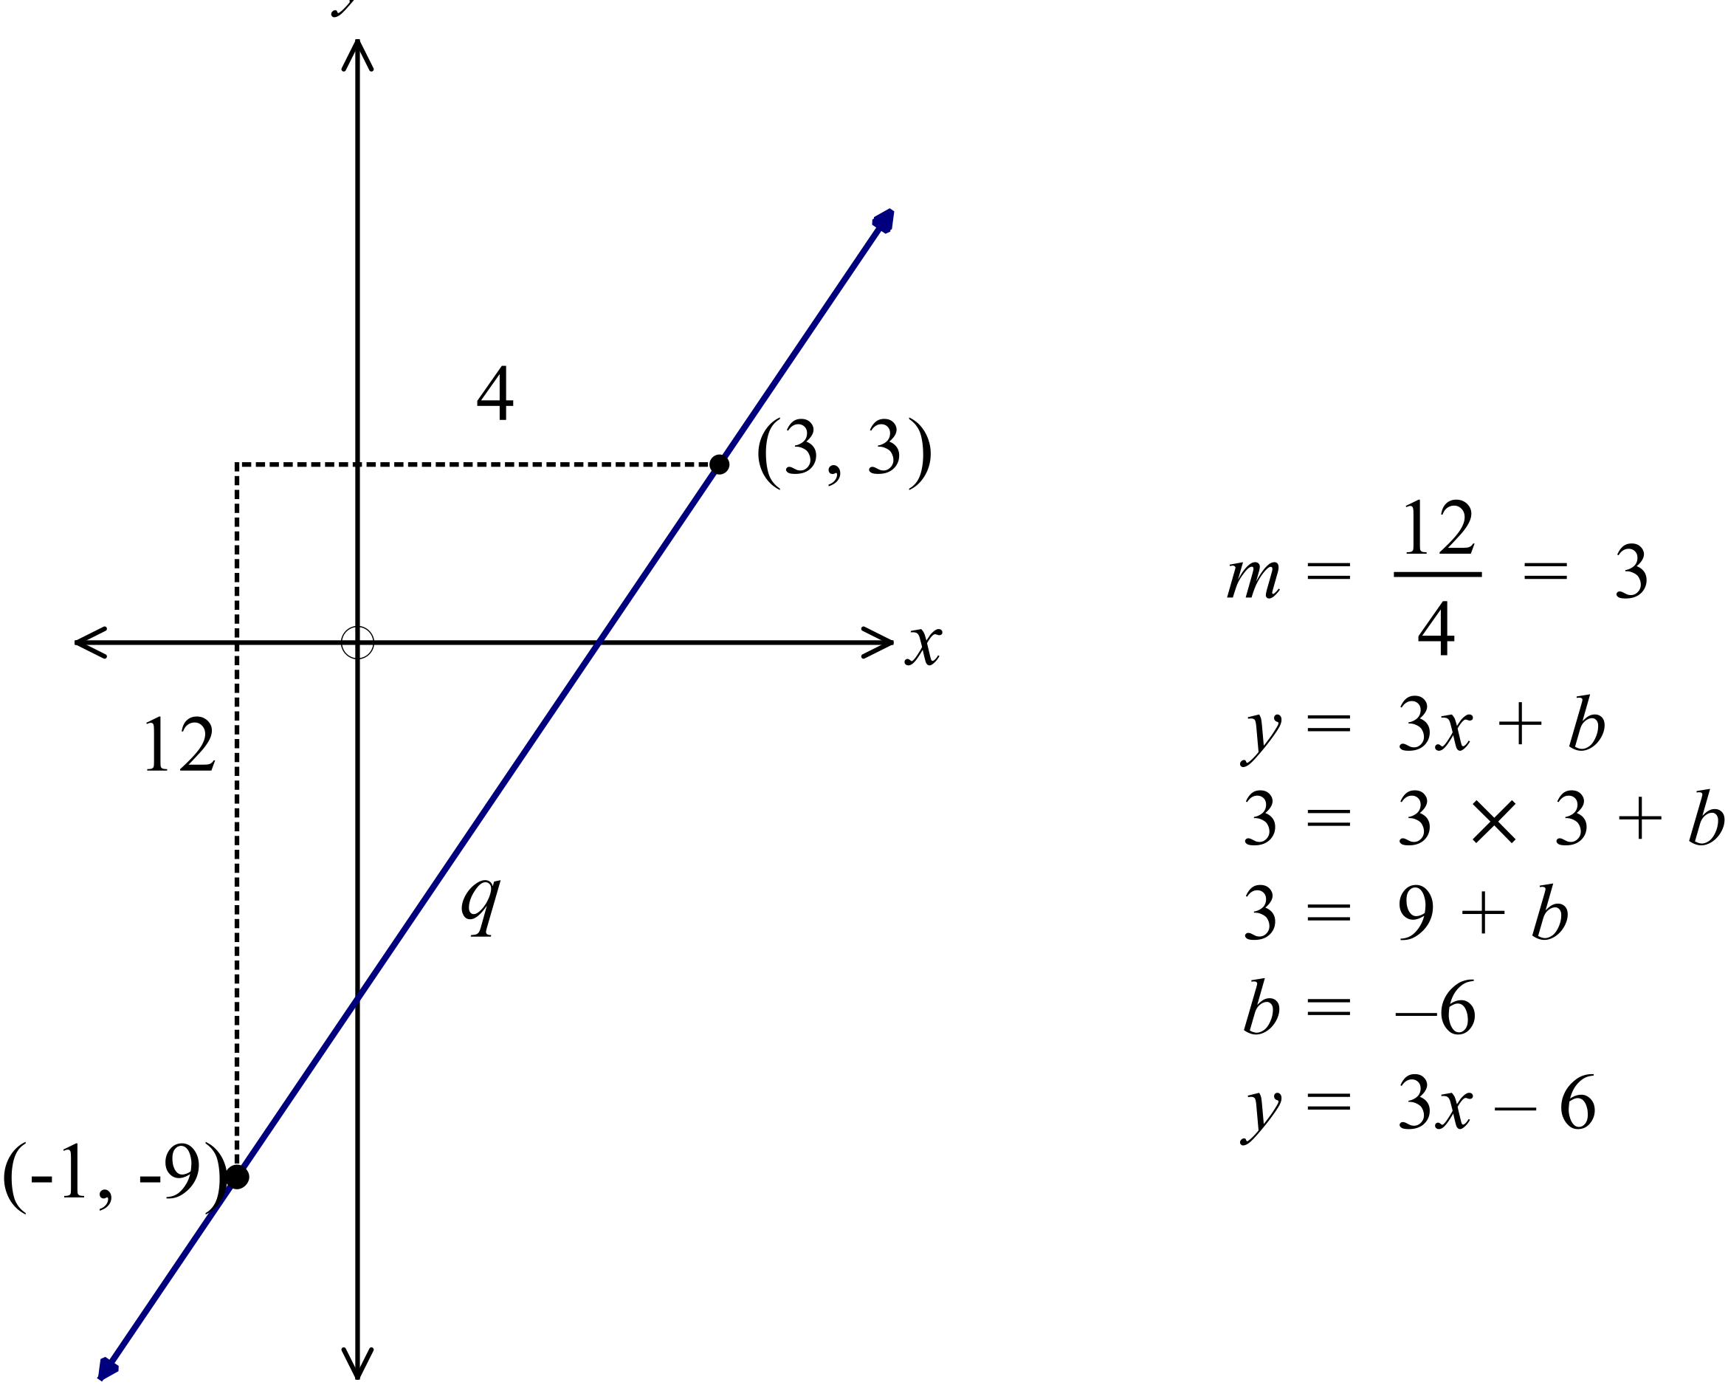 |  | 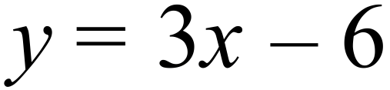
 | 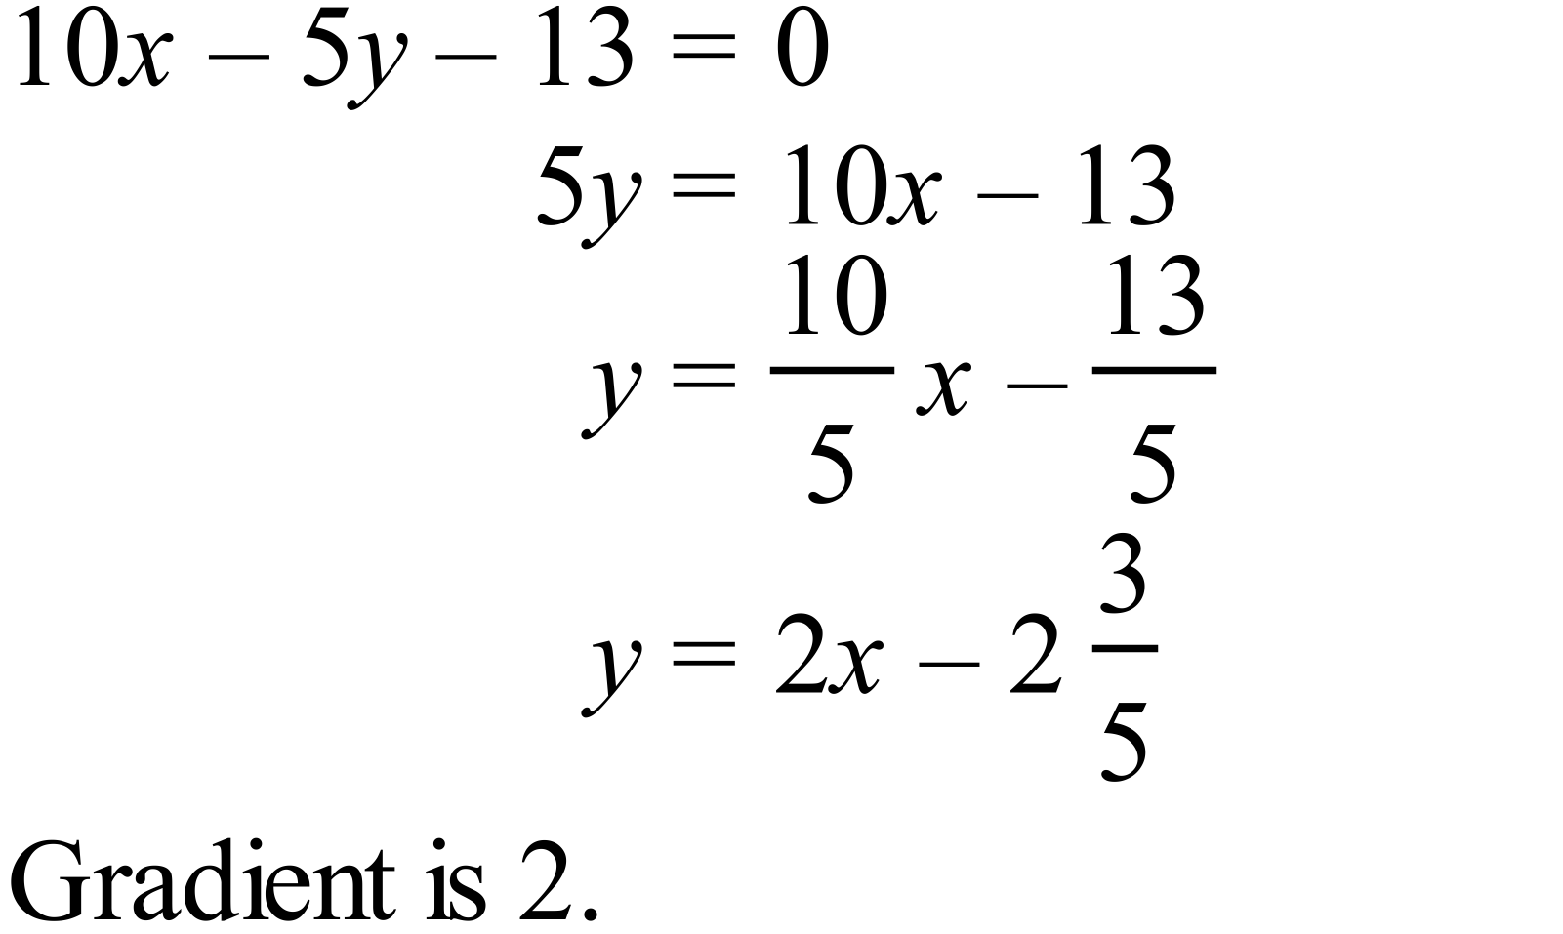 |  | 2
 | parallel to the line through the point  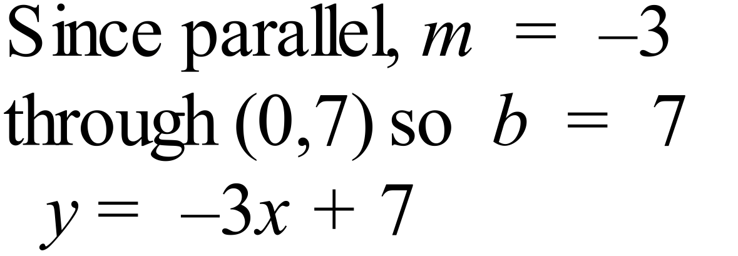 |  | 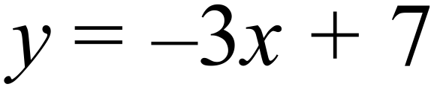
 | Parallel to the line through (2, 12).  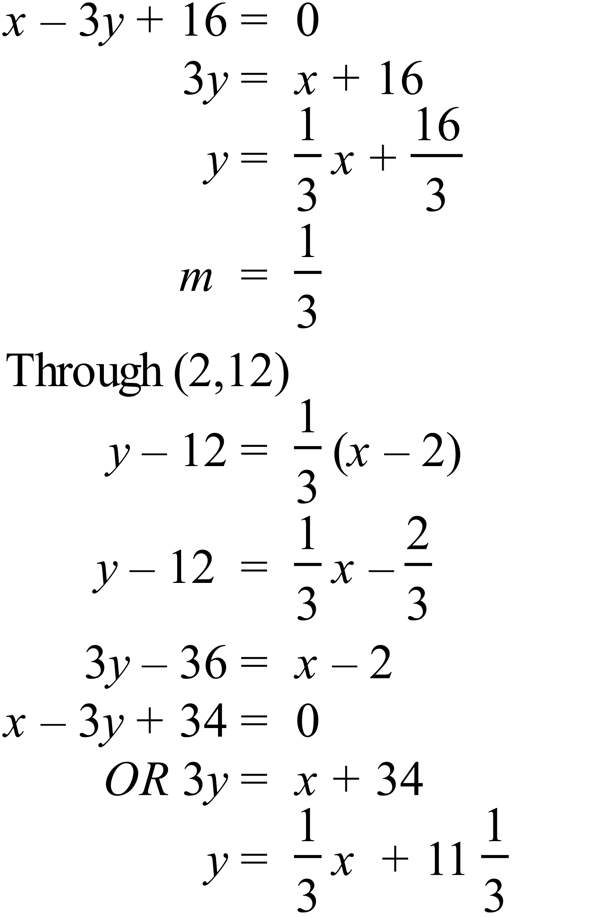 |  | 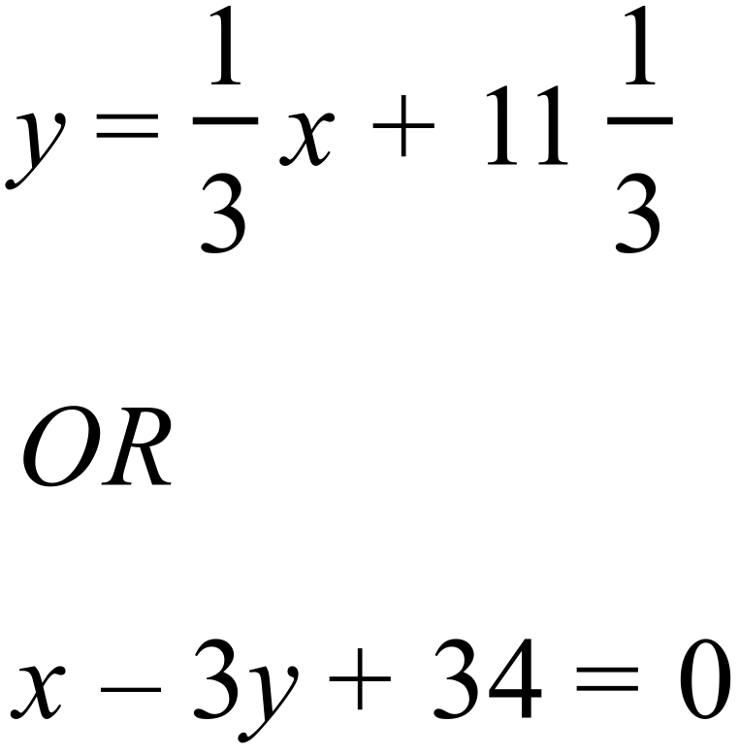
 | 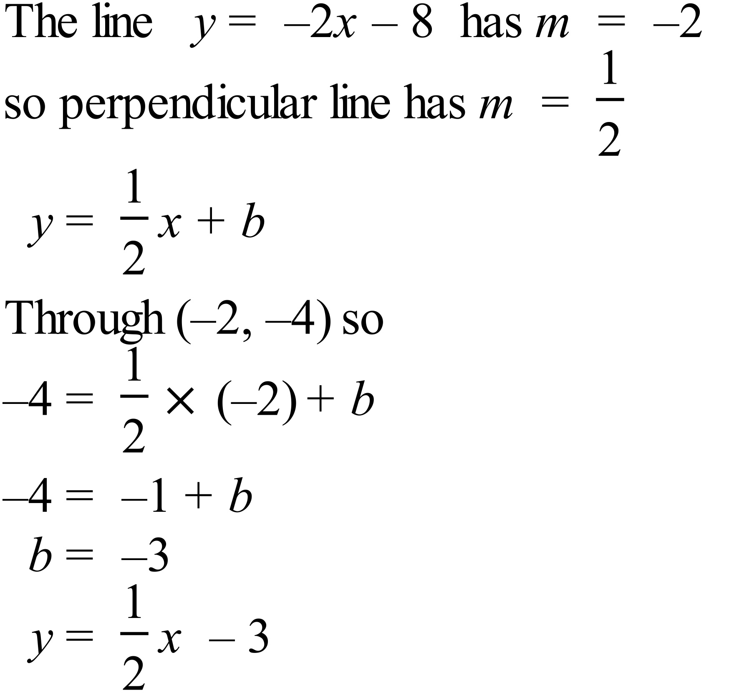 |  | 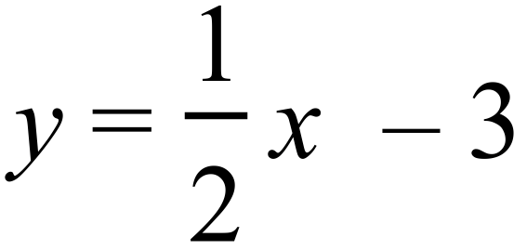

Year 10 |  | Linear Relations | Calculator Allowed
Section 2 Multiple Choice Section
ANSWERS
No. | WORKING |  |  | ANSWER
 | 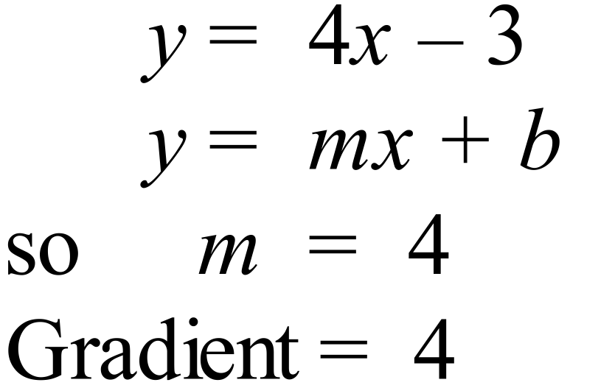 |  |  | D
 | So 10 is incorrect, should be 11. |  |  | C
   | 0 | 1 | 2 | 3
   | 3 | 7 | 11 | 15
 | Gradient of through 7 on the y axis.  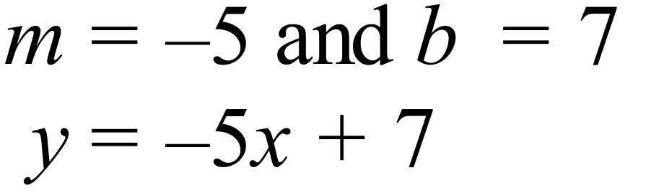 |  |  | B
 | 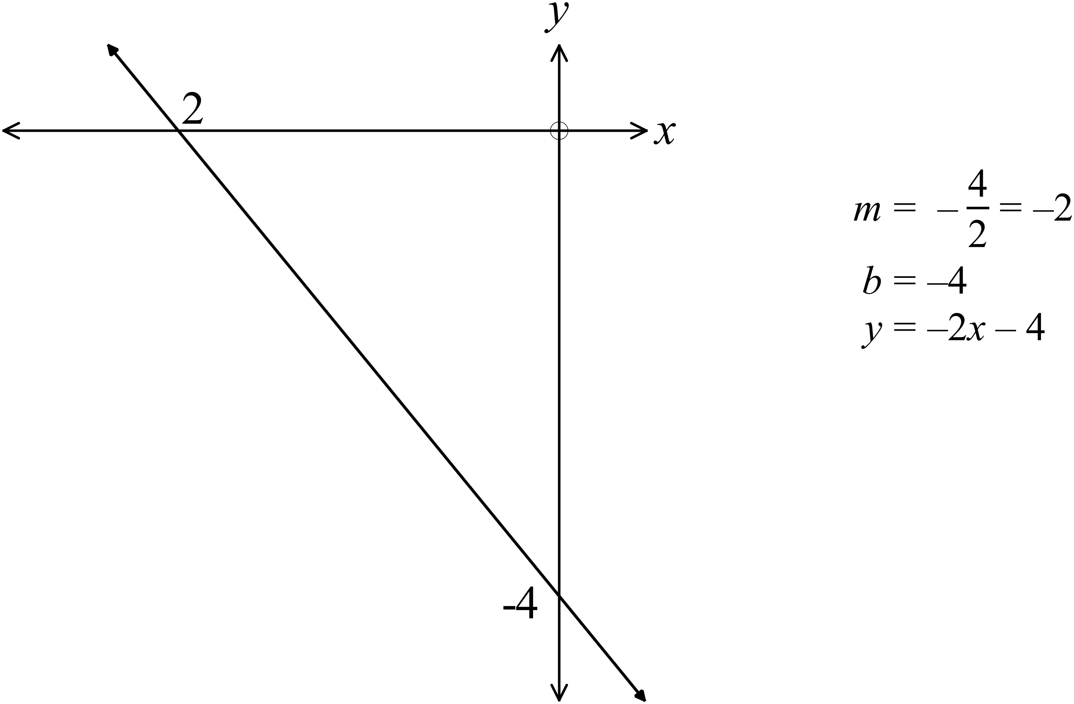 |  |  | B
 | 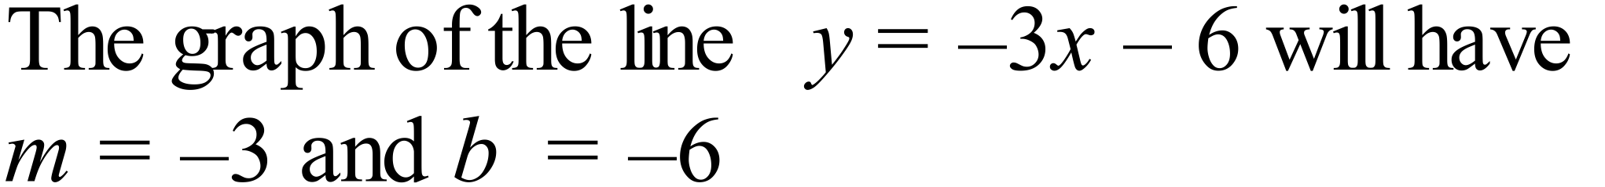 |  |  | C
 | 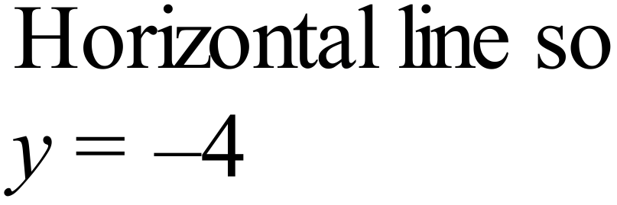 |  |  | A
 | Gradient of 4 and passes through the point  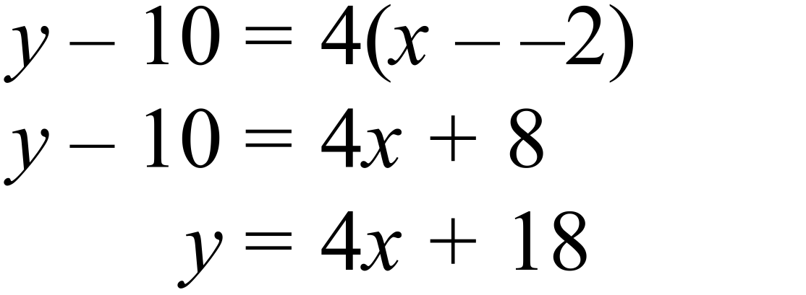 |  |  | D
 | (-2, -7) (-2, -14)  (-1, -8) (-1, -10) |  |  | B
 | 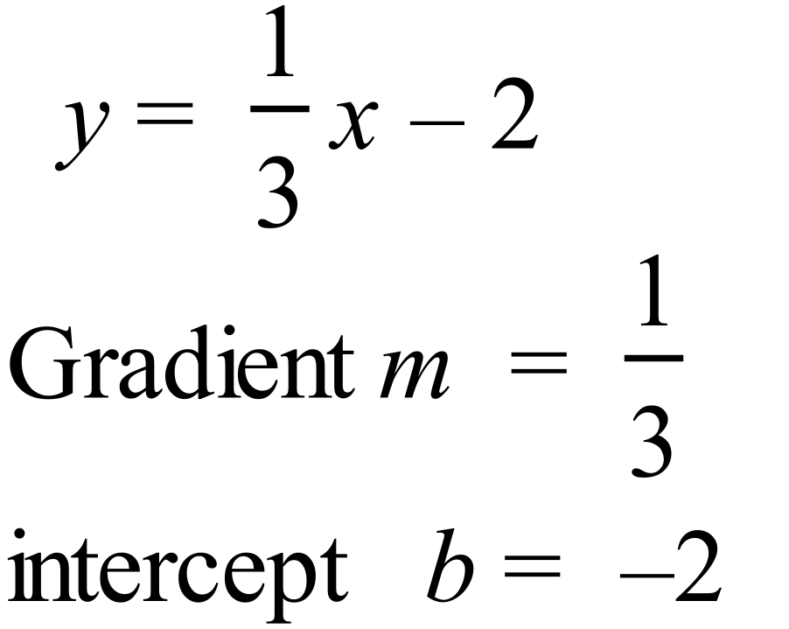 |  |  | C
 | 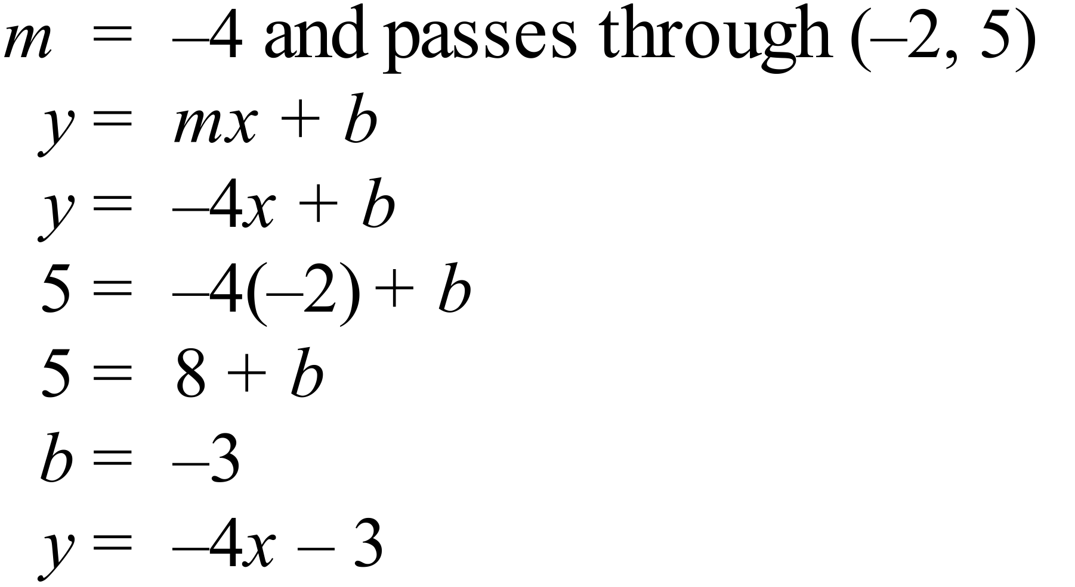  OR  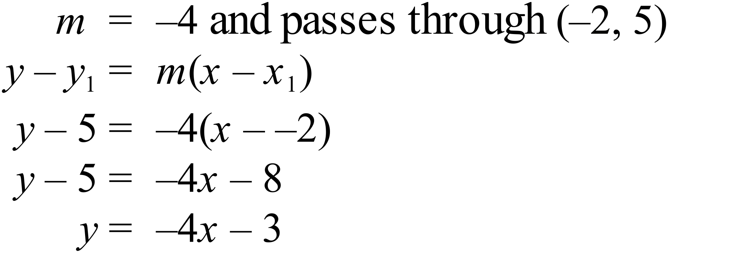 |  |  | A
 | 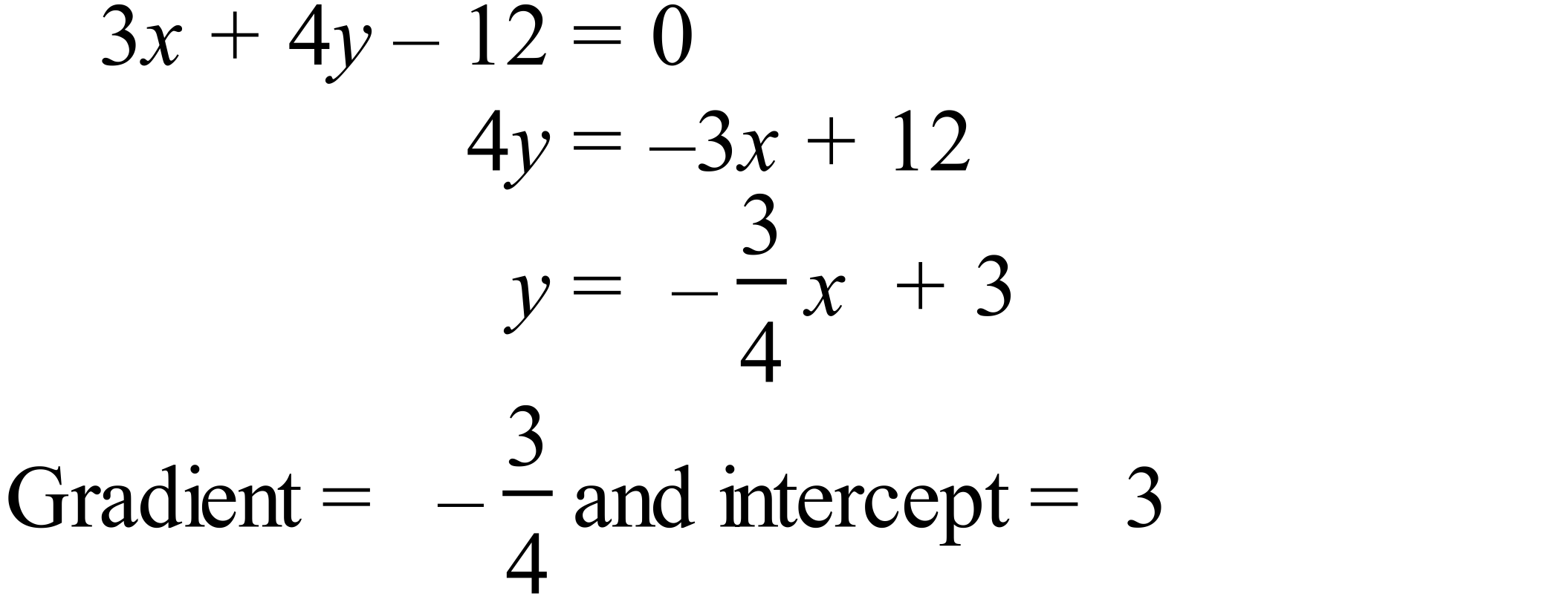 |  |  | C
 | For the points P and Q  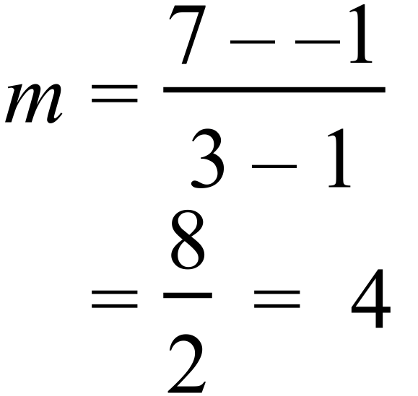  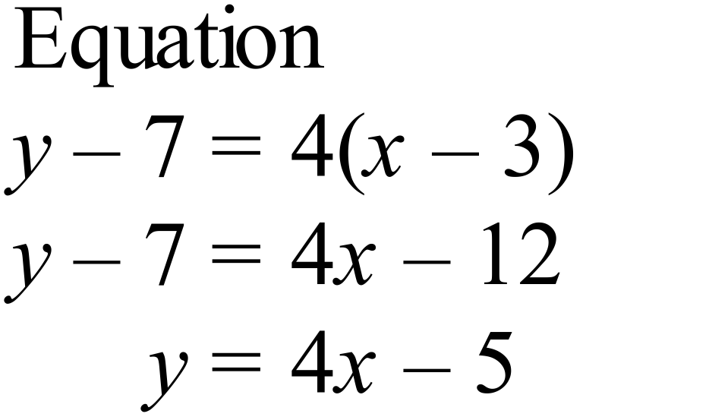 |  |  | B
 | No gradients are equal, so none parallel.  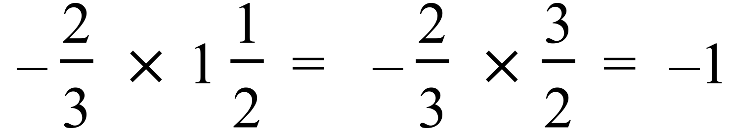  So line n is perpendicular to line q. |  |  | A
 | 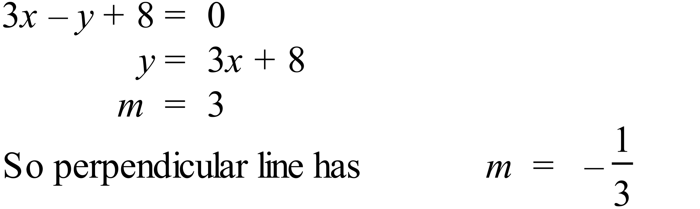 |  |  | D
 | 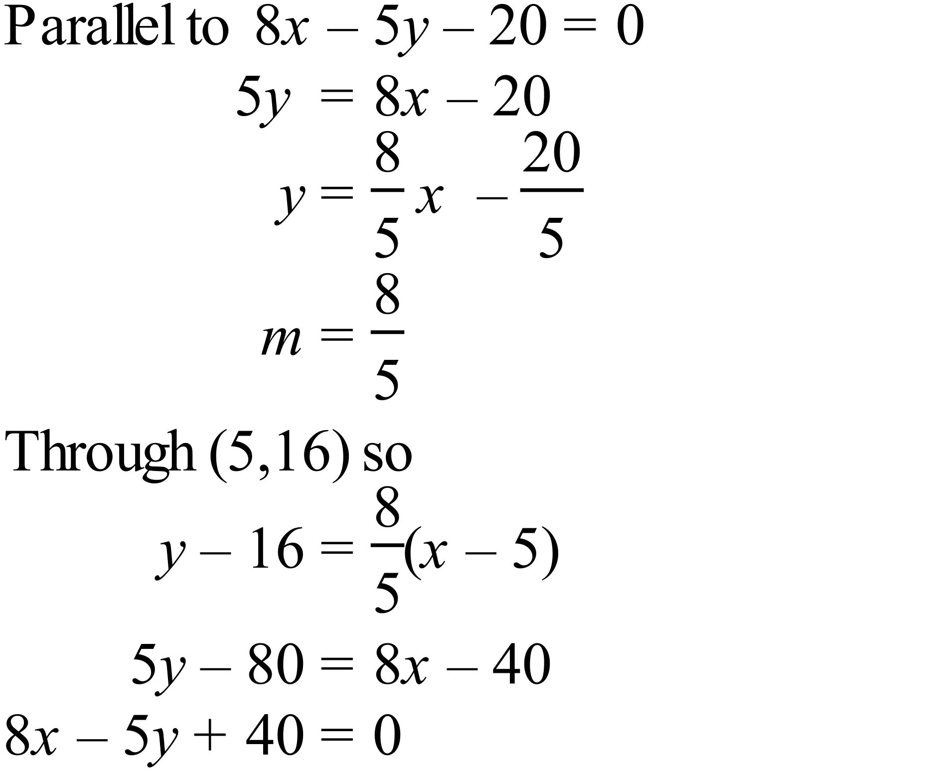 |  |  | D

Multiple Choice Answer Sheet
Linear Relations
Name _______ANSWERS_______________________________
Completely fill the response oval representing the most correct answer.

1. A B C D
2. A B C D
3. A B C D
4. A B C D
5. A B C D
6. A B C D
7. A B C D
8. A B C D
9. A B C D
10. A B C D
11. A B C D
12. A B C D
13. A B C D
14. A B C D
15. A B C D

